AK Solar Energy Series
Product Specification

Product Name: | GPS positioning terminal
Product Model: | AK-GT07E
File version: | V1.0
Version date: | 2025.06.18

version | Update content | Reviser | Revision time
V1.0 | Function description, specification parameters | Ah Xiang | 2025.06.18

catalogue
1. Basic product introduction 3
1.1 Product Introduction 3
1.2 Application areas 3
1.3 Product Image 3
1.4 Product usage introduction 4
1.4.1 SIM card installation method 4
1.4.2 Indicator light description 4
1.4.3 Work logic 4
2. Functional Features 5
3. Product parameters 6
3.1 Hardware specification parameters 6

Basic introduction of the product

1.1 Product Introduction
AK-GT07E is a 4G universal solar-powered positioning terminal meticulously crafted for the positioning of cargo fishing boats. It integrates 4G universal wireless communication technology and GPS/BDS satellite navigation and positioning technology. The terminal adopts an industrial-grade, highly integrated, fully built-in antenna design, with a built-in 3-axis sensor and intelligent power-saving wake-up function. It features an SOS emergency button, waterfall detection, rollover detection, and other functions. Three modes can be set to meet various application scenarios of customers, and users can send commands to switch working modes. With the global positioning service platform, the device location can be queried anytime, anywhere.

1.2 Application areas
Insurance industry, corporate fleet industry, automobile manufacturers/4S stores, electric new energy sector, passenger vehicles, taxis, rental vehicles, fishing boats, etc.

1.3 Product images

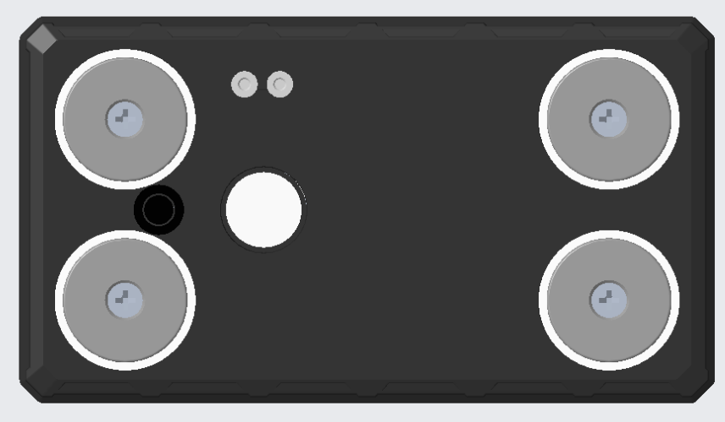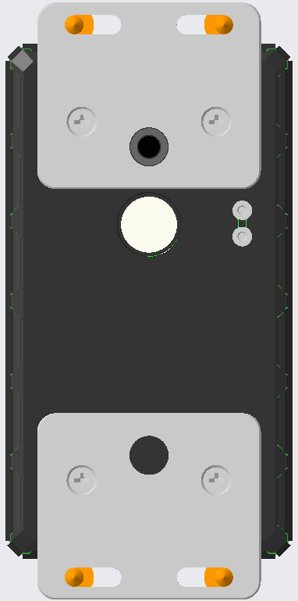
Two installation methods:
1. Strong magnetic adsorption
2. Screw fixation installation
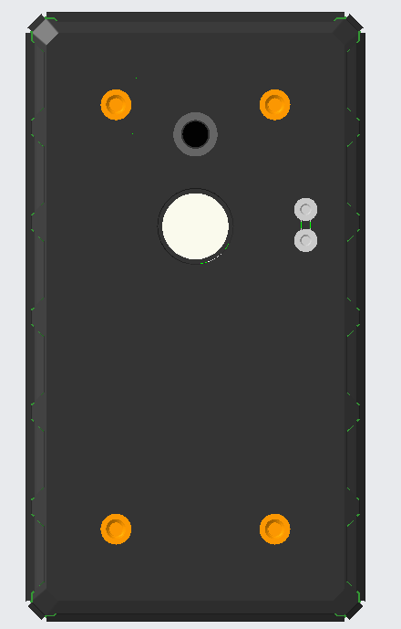
Water immersion detection contactor
Hall tamper sensor
Photosensitive tamper-proof sensor

1.4 Introduction to product usage

1.4.1 SIM card installation method
The device uses a Micro SIM card. The card slot is of a self-popping type. Place the chip side of the card facing the magnetic side, and insert the card into the slot with the notch facing inward.

1.4.2 Indicator light description
Red light - charging indicator light
The status of the light | meaning
Chang Liang | Charging
"Not bright" | Fully charged/off
Yellow light - GSM indicator light
The status of the light | meaning
Blink once within 2 seconds | GSM initialization
Chang Liang | GSM communication is normal
Not lit up | GSM sleep/shutdown
Blue light - GPS indicator light
The status of the light | meaning
Blink once within 2 seconds | In satellite signal search
Chang Liang | GPS/BDS has been positioned
Not lit up | GPS/BDS dormant
White light - SOS indicator light
The status of the light | meaning
flicker | Trigger SOS
not bright | SOS not activated

1.4.3 Working logic
Normal mode: In motion, the device transmits its location every 60 seconds by default. In a stationary state, it transmits its location every 1800 seconds by default. In a dormant state, the device transmits a heartbeat every 5 minutes to maintain a connection with the server. The device can be woken up to a working state by shaking it.
Power-saving mode: In motion state, the device transmits location data once every 60 seconds by default. In stationary state, it transmits location data once every 1800 seconds by default. In sleep state, the device does not transmit data. Disconnecting from the server saves power. The device can be woken up to working state by shaking it.
Intelligent mode: Set the data upload interval, and the device will operate according to the set interval, working for 2 minutes each time, except for
During working hours, the device is in a dormant state and cannot be woken up by vibration.

- Features
- Supports multiple functions such as vibration alarm, overspeed alarm, and removal alarm;
- Support the electronic fence function, where users can define a virtual electronic fence through the platform/APP. When the device enters or exits the fence, it can be recognized by the platform and an alarm will be issued;
- Solar charging, ultra-long battery life, and the ability to continue working without charging in power-saving mode;
- When an alarm occurs, an alert message or call can be sent to the monitoring number, and the alarm can be uploaded to the platform simultaneously;
- The terminal adopts an industrial-grade high-stability GPRS module from a well-known manufacturer, with a built-in GSM high-sensitivity antenna, supporting TCP/IP data transmission and connecting to servers via domain name/IP address;
- Equipped with a large-capacity storage chip, it supports data storage in offline mode and the supplementary transmission of blind-spot data. When the vehicle is in a place with weak wireless signals or severe interference, the onboard device will temporarily store the vehicle's operational data in FLASH. Once the wireless signal returns to normal, it can transmit these data, ensuring no data is lost.;
- Equipped with a built-in 3-axis accelerometer and integrated with precise acceleration algorithms, it can obtain real-time vehicle posture and other vehicle condition assessments;
- High-sensitivity GPS/BDS dual-satellite positioning module, equipped with an anti-interference ceramic antenna, ensures more stable satellite signal search, and supports AGPS for rapid positioning tracking and synchronous timing;
- Three working modes, adaptable to various scenarios.

Product Parameters
 | Function Name | have | none | Project function description
Electrical Characteristics | power supply method | ● |  | battery-powered
Electrical Characteristics | charge | ● |  | Solar charging & charging cable 5V/1A
Electrical Characteristics | Operating voltage range | ● |  | DC 3.4V - 4.5V
Electrical Characteristics | operating current | ● |  | 4V / Average 50mA
Electrical Characteristics | quiescent current | ● |  | 4V/less than 1mA
Electrical Characteristics | Built-in battery capacity | ● |  | 10000 mAh (3.7V polymer battery)
Environmental characteristics | Operating temperature range | ● |  | -20℃ - 75℃
Environmental characteristics | Storage temperature range | ● |  | -30℃ - 80℃
Environmental characteristics | Operating humidity range | ● |  | 10%-85% RH non-condensing
Communication characteristics | SIM card | ● |  | Micro SIM card
Communication characteristics | Communication frequency band | ● |  | LTE-FDD | B1/ 2/ 3/ 4/ 5/ 7/ 8/ 12/ 13/ 17/ 18/ 19/ 20/ 25/ 26/ 28/ 66
 |  |  |  | LTE-TDD | B34/ 38/ 39/ 40/ 41
 |  |  |  | GSM/2G | B2/ 3/ 5/ 8
Communication characteristics | Communication antenna | ● |  | built-in antenna
Communication characteristics | Antenna specifications | ● |  | FPC Antenna
GPS/BD positioning features | Positioning module brand/chip model | ● |  | Zhongke Micro AT6558R
GPS/BD positioning features | positioning method | ● |  | BeiDou + GPS
GPS/BD positioning features | Cold start time | ● |  | Average 32 seconds
GPS/BD positioning features | Hot start time | ● |  | On average, 1 second
GPS/BD positioning features | Tracking sensitivity | ● |  | -162 dBm
GPS/BD positioning features | positioning antenna | ● |  | built-in antenna
GPS/BD positioning features | Antenna Specifications | ● |  | 25mm * 25mm * 4mm
GPS/BD positioning features | GPS frequency band | ● |  | L1: 1575.42±1.023MHz
GPS/BD positioning features | BeiDou frequency band | ● |  | B1: 1561.098±2.046MHz
GPS/BD positioning features | Number of satellite channels | ● |  | 32
GPS/BD positioning features | positioning accuracy | ● |  | <10m（1σ）
GPS/BD positioning features | Timing accuracy | ● |  | <30ns（1σ）
GPS/BD positioning features | speed measurement accuracy | ● |  | <0.1m/s（1σ）
GPS/BD positioning features | maximum acceleration | ● |  | 4g
GPS/BD positioning features | maximum speed | ● |  | 515m/s
GPS/BD positioning features | maximum height | ● |  | 18000m
external interface | Tamper detection | ● |  | Support magnetic Hall tamper detection
external interface | Water immersion detection | ● |  | Support water-fall detection points
Specifications | Host dimensions (length, width, height) | ● |  | 138mm * 77mm * 30mm
Specifications | Installation method | ● |  | Magnetic attraction/screw (optional: choose one from two)
Specifications | Shell material | ● |  | ABS plastic
Specifications | IP protection rating | ● |  | IP67
Specifications | host weight | ● |  | 300 G

