AK grazing cattle and sheep specification 20000 basic product introduction

1.1 Product Introduction
C035 is a meticulously crafted 4G full-network compatible smart positioning terminal specifically designed for cattle and sheep. It integrates 4G full-network compatible wireless communication technology and GPS/BDS satellite navigation and positioning technology. The terminal adopts an industrial-grade, highly integrated design with fully built-in antennas. The device is equipped with a 3-axis sensor and features intelligent power-saving wake-up functionality. It offers functions such as real-time positioning, vibration alarm, light-based pet locating, sound-based pet locating, and roll-call positioning. Four working modes can be set to cater to various customer application scenarios, and users can send commands to switch between these modes. When paired with a global positioning service platform, the device's location can be queried anytime, anywhere.

1.2 Application areas
Cargo tracking, pet tracking, passenger vehicles, etc. 1.3 Product images
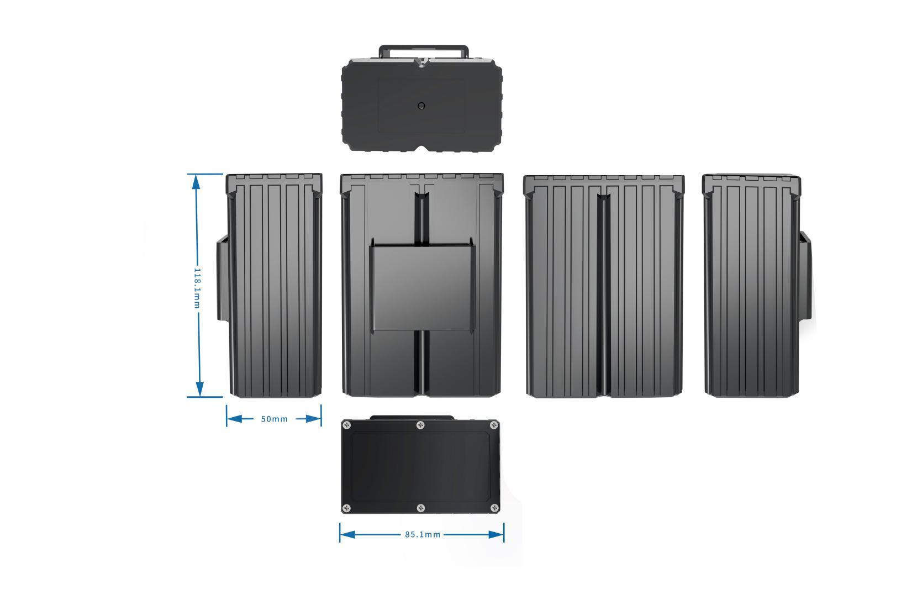

1.4 Introduction to product usage

1.4.1 SIM card installation method
The device uses a Nona SIM card. The card slot is of a self-popping type, and the card notch is inserted into the slot facing inward.

1.4.2 Indicator light description
Red light - charging indicator light
The status of the light | meaning
Chang Liang | Charging
"Not bright" | Fully charged
Yellow light - GSM indicator light
The status of the light | meaning
Blink once within 2 seconds | GSM initialization
Chang Liang | GSM communication is normal
"Not bright" | GSM sleep/shutdown
Blue light - GPS indicator light
The status of the light | meaning
Blink once within 2 seconds | In satellite signal search
Chang Liang | GPS/BDS has been positioned
Not lit up | GPS/BDS in hibernation

1.4.3 Working logic
① Status description:
Power on/off status: The device can be powered on or off by pressing and holding the button for three seconds. No data will be uploaded after powering off
Working status: The device's working light is on, and both GPRS and GPS are in working status.
Standby state: The device is operating in GPRS mode (the platform remains online, allowing online command and SMS issuance), but GPS is not operational.

② Description of working mode:
Continuous positioning: The device is in working state by default, and updates its location every 30 seconds by default;
Normal mode: The device is in standby mode by default. During this period, if vibration is detected, it will enter working mode and update its location every 10 minutes. If no vibration is detected, it will remain in standby mode;
Power-saving mode: The device is in standby mode by default. During this period, if vibration is detected, it will enter working mode and update its location once every hour. If no vibration is detected, it will remain in standby mode;
Standby mode: The device is in standby mode by default. During this period, if vibration is detected, it will enter working mode and update its location every 12 hours. If no vibration is detected, it will remain in standby mode;

③ Vibration alarm instructions:
After the platform issues a security setting command, the device will enter a secured state after being idle for three minutes. Upon detecting vibration, it will upload a vibration alarm. The security setting is only effective once.

Features
- Multiple positioning with GPS+BDS+AGPS+LBS;
- Support electronic fence function, where users can define a virtual electronic fence through the platform/APP. When the device enters or exits the fence, it can be recognized by the platform and an alarm will be issued;
- When an alarm occurs, an alert message or call can be sent to the monitoring number, and the alarm can be uploaded to the platform simultaneously;
- The terminal utilizes an industrial-grade, high-stability GPRS module from a renowned manufacturer, equipped with a built-in GSM high-sensitivity antenna. It supports TCP/IP data transmission and allows for connection to servers via domain names or IP addresses;
- Equipped with a large-capacity storage chip, it supports data storage in offline mode and the supplementary transmission of blind-spot data. When the wireless signal is weak or severely interfered in areas where pets are present, the data of the pets' movements is temporarily stored in FLASH. Once the wireless signal returns to normal, these data can be supplemented, ensuring no data is lost;
- Equipped with a built-in 3-axis accelerometer, it integrates precise acceleration algorithms to obtain real-time information about the pet's current posture and other conditions;
- High-sensitivity GPS/BDS dual-satellite positioning module, equipped with an anti-interference ceramic antenna, ensures more stable satellite signal search, and supports AGPS for rapid positioning tracking and synchronous timing;
- Support online remote upgrade and remote configuration of product parameters;
- The historical trajectory platform retains data for 180 days.

Product Parameters
 | Function Name | have | none | Project function description
Electrical Characteristics | power supply method | ● |  | battery-powered
Electrical Characteristics | Operating voltage range | ● |  | DC 3.4V - 4.5V
Electrical Characteristics | Operating state Voltage/Current | ● |  | 4V/60mA average
Electrical Characteristics | Standby state Voltage/Current | ● |  | 4V/5mA, average
Electrical Characteristics | Built-in battery capacity | ● |  | 20000 mAh (3.7V polymer battery)
Environmental characteristics | Operating temperature range | ● |  | -20℃ - 75℃
Environmental characteristics | Storage temperature range | ● |  | -30℃ - 80℃
Environmental characteristics | Operating humidity range | ● |  | 10%-85% RH non-condensing
Communication characteristics | Communication module brand/chip model | ● |  | SIMCOM 7670C-LASE
Communication characteristics | Communication frequency band | ● |  | LTE/4G | LTE-FDD:B1/B3/B5/B8
 |  |  |  |  | LTE-TDD:B34/B38/B39/B40/B41
 |  |  |  | GSM/2G | 900/1800 MHz
Communication characteristics | SIM card | ● |  | Nona SIM card
Communication characteristics | Communication antenna | ● |  | Built-in FPC antenna
GPS/BD positioning characteristics | Positioning module brand/chip model | ● |  | AT6558R
GPS/BD positioning characteristics | positioning method | ● |  | BDS/GPS/GLONASS
GPS/BD positioning characteristics | Cold start time | ● |  | Average: 32 seconds
GPS/BD positioning characteristics | Hot start time | ● |  | On average, 1 second
GPS/BD positioning characteristics | Tracking sensitivity | ● |  | -162 dBm
GPS/BD positioning characteristics | positioning antenna | ● |  | built-in antenna
GPS/BD positioning characteristics | Antenna Specifications | ● |  | 18mm×18mm×2mm
GPS/BD positioning characteristics | GPS frequency band | ● |  | L1: 1575.42±1.023MHz
GPS/BD positioning characteristics | BeiDou frequency band | ● |  | B1: 1561.098±2.046MHz
GPS/BD positioning characteristics | Number of satellite channels | ● |  | 32
GPS/BD positioning characteristics | positioning accuracy | ● |  | <2m（1σ）
GPS/BD positioning characteristics | Timing accuracy | ● |  | <30ns（1σ）
GPS/BD positioning characteristics | speed measurement accuracy | ● |  | <0.1m/s（1σ）
external interface | charging port | ● |  | Route 1
Specifications | Host dimensions (length, width, height) | ● |  | 110 mm* 77mm *46mm
Specifications | Shell material | ● |  | ABS plastic
Specifications | IP protection rating | ● |  | IP67
Specifications | host weight | ● |  | 476.5 grams

