International car charger GPS

Product Specification

Product Name: | GPS positioning terminal
Product Model: | C036
File version: | V1.0
Version date: | 2025.6.18

version | Update content | Reviser | Revision time
V1.0 | Function description, specification parameters | Ah Xiang | 2025.6.18

catalogue
1. 产品基本介绍 3
1.1产品简介 3
1.2应用领域 3
1.3产品图片 3
1.4产品使用介绍 4
1.4.1 SIM卡安装方式 4
1.4.2 指示灯说明 4
1.4.3 工作逻辑 4
2. 功能特点 5
3. 产品参数 6
硬件规格参数 6

- Basic introduction of the product

1.1 Product Introduction
C036 is a 4G full-network vehicle charging and positioning terminal meticulously crafted for the Internet of Vehicles. It integrates 4G full-network wireless communication technology and GPS/BDS satellite navigation and positioning technology. The terminal adopts an industrial-grade, highly integrated, fully built-in antenna design, with built-in 3-axis sensors and intelligent power-saving wake-up functionality. It features vibration alarm, overspeed alarm, power failure alarm, and other functions. When paired with a global positioning service platform, the device's location can be queried anytime, anywhere.

1.2 Application Fields
Insurance industry, corporate fleet industry, automobile manufacturers/4S stores, individual users, electric new energy sector, passenger vehicles, taxi services, rental vehicles, etc.

1.3 Product images

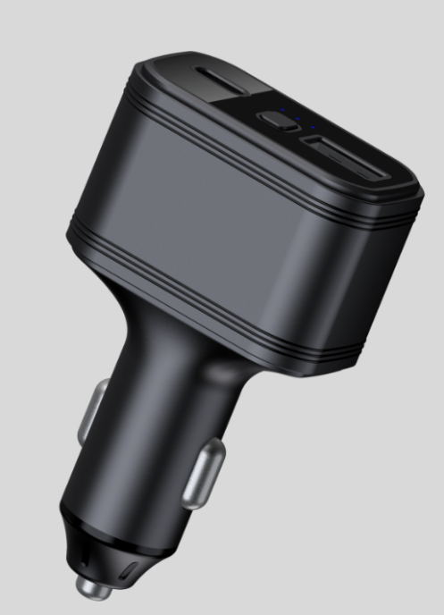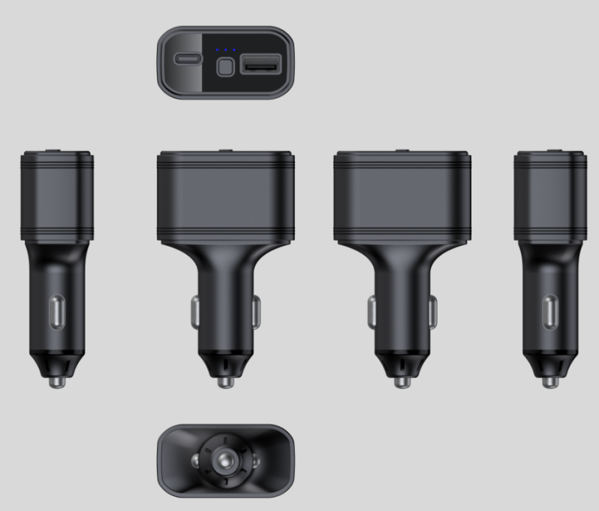

1.4 Introduction to product usage

1.4.1 SIM card installation method
The device uses a nano SIM card. The card slot is of a self-popping type. Place the chip side of the card facing the USB charging port, and insert the card into the slot with the notch facing inward.

1.4.2 Indicator light description
Red light - breathing light
The status of the light | meaning
slow flash | Power-on is normal
Not lit up | The power supply is not connected
Yellow light - GSM indicator light
The status of the light | meaning
Flash once within 3 seconds | GSM initialization
Chang Liang | GSM communication is normal
Not lit up | GSM sleep/shutdown
Blue light - GPS indicator light
The status of the light | meaning
Flash once within 3 seconds | In satellite signal search
Chang Liang | GPS/BDS has been positioned
"Not bright" | GPS/BDS dormant

1.4.3 Working logic
After the equipment is installed, and the yellow and blue lights are constantly on, the equipment enters its normal working state.
In the stationary and flameout state: the device sends one piece of data every 5 minutes.
Motion ignition status: The device sends one data point every 20 seconds.

- Features
- Multiple functions such as vibration alarm, overspeed alarm, and removal alarm;
- Support electronic fencing function, where users can define virtual electronic fences through the platform/APP. When devices enter or exit the fences, they can be recognized by the platform and an alarm will be issued;
- The terminal adopts an industrial-grade high-stability GPRS module from a well-known manufacturer, with a built-in high-sensitivity communication antenna, supporting TCP/IP data transmission and domain name/IP address connection to servers;
- Equipped with a large-capacity storage chip, it supports data storage in offline mode and the supplementary transmission of blind-spot data. When the vehicle is in an area with weak wireless signals or severe interference, the onboard device will temporarily store the vehicle's operational data in FLASH. Once the wireless signal returns to normal, it can transmit these data to ensure no data is lost.;
- Equipped with a built-in 3-axis accelerometer and integrated with precise acceleration algorithms, it can obtain the current vehicle posture and other vehicle conditions in real-time;
- High-sensitivity GPS/BDS dual-satellite positioning module, equipped with an anti-interference ceramic antenna, ensures more stable satellite signal search, and supports AGPS for rapid positioning tracking and synchronous timing;
- Support online remote upgrade and remote configuration of product parameters.
- Product Parameters

3.1 Hardware specification parameters
 | Function Name | have | none | Project function description
Electrical Characteristics | power supply method | ● |  | battery-powered
Electrical Characteristics | Operating voltage range | ● |  | DC 9V - 32V
Electrical Characteristics | operating current | ● |  | 12V/65mA
Electrical Characteristics | quiescent current | ● |  | 12V / average 10mA
Electrical Characteristics | Built-in battery capacity | ● |  | 50 mAh (3.7V polymer battery)
Environmental characteristics | Operating temperature range | ● |  | -20℃ - 75℃
Environmental characteristics | Storage temperature range | ● |  | -30℃ - 80℃
Environmental characteristics | Operating humidity range | ● |  | 10%-85% RH non-condensing
Communication characteristics | SIM card | ● |  | Nano SIM card
Communication characteristics | Communication frequency band | ● |  | LTE/4G | LTE-FDD:B1/B2/B3/B4/B5/B7/B8/B12/B13/ B18/B19/B20/  B25/B26/B28/B66/  LTE-TDD :B34/B38/B39/B40/B41
 |  |  |  | GSM/2G | 850/900/1800/1900MHz
Communication characteristics | Communication antenna | ● |  | built-in antenna
Communication characteristics | Antenna specifications | ● |  | FPC Antenna
GPS/BD positioning characteristics | positioning method | ● |  | BeiDou + GPS + LBS
GPS/BD positioning characteristics | Cold start time | ● |  | Average 32 seconds
GPS/BD positioning characteristics | Hot start time | ● |  | On average, 1 second
GPS/BD positioning characteristics | Tracking sensitivity | ● |  | -162 dBm
GPS/BD positioning characteristics | positioning antenna | ● |  | built-in antenna
GPS/BD positioning characteristics | Antenna Specifications | ● |  | 25mm * 25mm * 2mm
GPS/BD positioning characteristics | GPS frequency band | ● |  | L1: 1575.42±1.023MHz
GPS/BD positioning characteristics | BeiDou frequency band | ● |  | B1: 1561.098±2.046MHz
GPS/BD positioning characteristics | Number of satellite channels | ● |  | 32
GPS/BD positioning characteristics | positioning accuracy | ● |  | <10m（1σ）
GPS/BD positioning characteristics | Timing accuracy | ● |  | <30ns（1σ）
GPS/BD positioning characteristics | speed measurement accuracy | ● |  | <0.1m/s（1σ）
GPS/BD positioning characteristics | maximum acceleration | ● |  | 4g
GPS/BD positioning characteristics | maximum speed | ● |  | 515m/s
GPS/BD positioning characteristics | maximum height | ● |  | 18000m
external interface | Charging interface TYPE-A | ● |  | DC: 5V/2A; 9V/2A
external interface | Charging interface TYPE-C | ● |  | DC: 5V/2A; 9V/2A
external interface | SOS | ● |  | Support SOS button
Specifications | Host dimensions (length, width, height) | ● |  | 85mm*49.2mm*26mm
Specifications | Shell material | ● |  | ABS+PC
Specifications | host weight | ● |  | 41 grams

