Basic introduction to AK waterproof wiring products

1.1 Product Introduction
AK-GT02XSA is a vehicle positioning terminal meticulously crafted for the Internet of Vehicles. It integrates GSM wireless communication technology and GPS/BDS satellite navigation and positioning technology. The terminal adopts an industrial-grade, highly integrated, fully built-in antenna design. The device is equipped with a 3-axis sensor and intelligent power-saving wake-up function. It features DC detection, ACC detection, vibration alarm, power failure alarm, overspeed alarm, and illegal start alarm. When paired with a global positioning service platform, it enables real-time acquisition and tracking of vehicle data.

1.2 Application areas
Insurance industry, corporate fleet industry, automobile manufacturers/4S stores, individual users, electric new energy sector, passenger vehicles, taxi services, rental vehicles, etc.

1.3 Product images
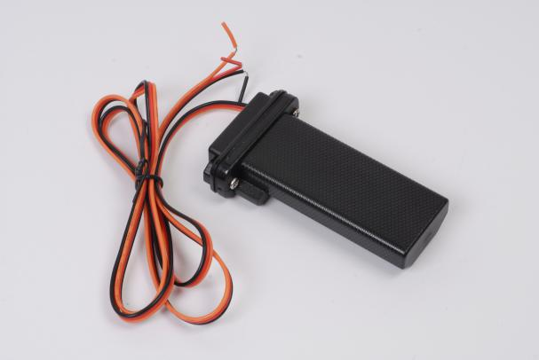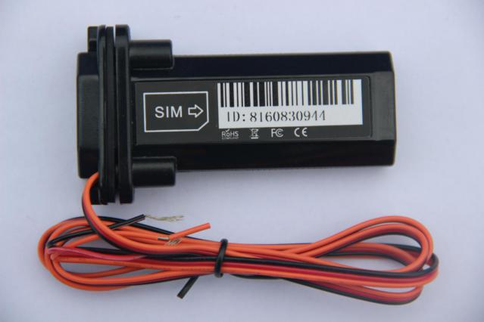

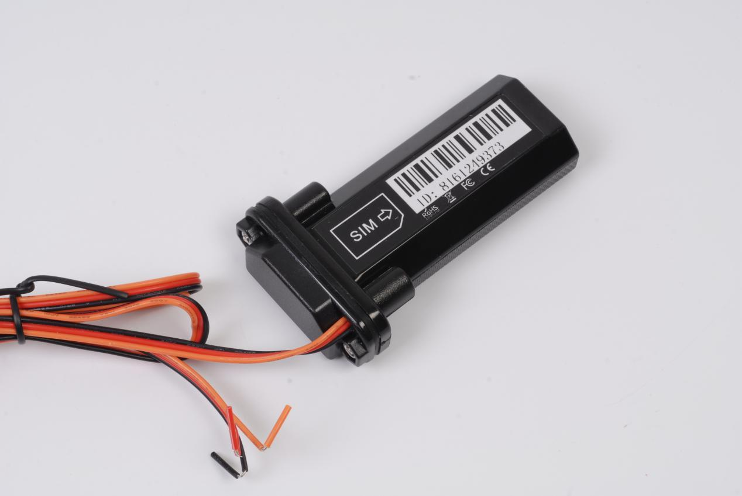

1.4 Introduction to product usage

1.4.1 SIM card installation method
The device uses a standard SIM card. The card slot is of the self-ejecting type, with the chip side facing the antenna direction, and the card notch inserted into the slot with the notch facing inward.

1.4.2 Indicator light description
Yellow light - GSM indicator light
The status of the light | meaning
Flash once within 2 seconds | GSM initialization
Chang Liang | GSM communication is normal
not bright | GSM sleep/shutdown

Blue light - GPS indicator light
The status of the light | meaning
Flash once within 2 seconds | In satellite signal search
Chang Liang | Located
not bright | dormancy

1.4.3 Working logic
After the equipment is installed, and the yellow and blue lights are constantly on, the equipment enters its normal working state.

Working logic: When ACC is on, the device does not sleep and uploads a piece of data every 20 seconds. When ACC is off, the device uploads data after being idle for 10 minutes
"Dormant, after entering dormancy, the device only transmits heartbeat data. During the period of inactivity, if vibration is detected, the device will reset the count."
"10 minutes of sleep.".

Vibration alarm: After being armed, the vibration device will trigger a vibration alarm. Once the vibration alarm is triggered, it is necessary to remain stationary for 5 minutes before
The alarm can be triggered again.

Displacement alarm: When the device is armed and in a positioning state, set a displacement alarm distance. If the device travels beyond this line segment distance, an alarm will be triggered
A displacement alarm will be reported, and the device will automatically disarm.

Power-off alarm: After the device is plugged in, it will detect the power supply. If the power supply is disconnected, the device will trigger an alarm 3 seconds after the disconnection
Trigger a power-off alarm and upload it to the server.

Illegal start alarm: After activating the illegal start alarm, when the device is armed and ignited in the disarmed state, the device will go
Report illegal start alarm. (ACC needs to be properly connected)

- Features
- Supports multiple alarm functions such as vibration alarm, power failure alarm, overspeed alarm, and illegal start alarm;
- Support the electronic fence function, where users can define a virtual electronic fence through the platform/APP. When the device enters or exits the fence, it can be recognized by the platform and an alarm will be issued;
- When an alarm occurs, an alert message or call can be sent to the monitoring number, and the alarm can be uploaded to the platform simultaneously;
- The terminal adopts an industrial-grade high-stability GPRS module, equipped with a built-in GSM high-sensitivity antenna, supports TCP/IP data transmission, and supports connecting to servers via domain name/IP address;
- Equipped with a high-capacity storage chip, it supports data storage in offline mode and the supplementary transmission of blind-spot data. When the vehicle is in an area with weak wireless signals or severe interference, the onboard device will temporarily store the vehicle's operational data in FLASH. Once the wireless signal returns to normal, it can transmit these data, ensuring no data is lost.;
- Equipped with a built-in 3-axis accelerometer and integrated with precise acceleration algorithms, it can obtain real-time vehicle posture and other vehicle condition assessments;
- High-sensitivity GPS/BDS dual-satellite positioning module, equipped with an anti-interference ceramic antenna, ensures more stable satellite signal search. It supports AGPS for rapid positioning tracking and synchronous timing;
- In sleep mode, automatic reporting of messages such as abnormal vibration alarms, vehicle start-up, shutdown, and sleep;
- Low-power energy-saving mode, accurately and reliably determining the ignition and flameout status of the car, and intelligent sleep and wake-up mechanisms can reduce the average power consumption of the entire system.

- Product Parameters

3.1 Hardware specification parameters
project | Function Name | have | none | Functional Description
Electrical Characteristics | power supply method | ● |  | Powered by battery
Electrical Characteristics | Operating voltage range | ● |  | DC 9V - 95V
Electrical Characteristics | operating current | ● |  | 12V / average 40mA
Electrical Characteristics | quiescent current | ● |  | 12V/less than 10mA
Electrical Characteristics | Built-in battery capacity | ● |  | 60 mAh (3.7V polymer battery) optional
Environmental characteristics | Operating temperature range | ● |  | -20℃ - 75℃
Environmental characteristics | Storage temperature range | ● |  | -30℃ - 80℃
Environmental characteristics | Operating humidity range | ● |  | 10%-85% RH non-condensing
Communication characteristics | Communication module brand/chip model | ● |  | SIMCOM 7670SA
Communication characteristics | Communication frequency band | ●  ● |  | LTE/4G | LTE-FDD:B1/B2/B3/B4/B5/B7/B8/B28/B66
 |  |  |  | GSM/2G | 850/900/1800/1900MHz
Communication characteristics | SIM card | ● |  | Standard SIM card
Communication characteristics | Communication antenna | ● |  | built-in antenna
GPS/BD positioning characteristics | Positioning module brand/chip model | ● |  | Zhongke Micro AT6558D
GPS/BD positioning characteristics | positioning method | ● |  | BeiDou + GPS
GPS/BD positioning characteristics | Cold start time | ● |  | Average 32 seconds
GPS/BD positioning characteristics | Hot start time | ● |  | Average 1 second
GPS/BD positioning characteristics | Tracking sensitivity | ● |  | -162 dBm
GPS/BD positioning characteristics | positioning antenna | ● |  | built-in antenna
GPS/BD positioning characteristics | Antenna Specifications | ● |  | 25mm * 25mm * 4mm
GPS/BD positioning characteristics | GPS frequency band | ● |  | L1: 1575.42±1.023MHz
GPS/BD positioning characteristics | BeiDou frequency band | ● |  | B1: 1561.098±2.046MHz
GPS/BD positioning characteristics | Number of satellite channels | ● |  | 32
GPS/BD positioning characteristics | positioning accuracy | ● |  | <10m（1σ）
GPS/BD positioning characteristics | Timing accuracy | ● |  | <30ns（1σ）
GPS/BD positioning characteristics | speed measurement accuracy | ● |  | <0.1m/s（1σ）
GPS/BD positioning characteristics | maximum acceleration | ● |  | 4g
GPS/BD positioning characteristics | maximum speed | ● |  | 515m/s
GPS/BD positioning characteristics | maximum height | ● |  | 18000m
external interface | Cut off fuel and electricity | ● |  | Optional features
external interface | ACC detection input | ●
Specifications | Host dimensions (length, width, height) | ● |  | 90.6mm * 34mm * 20mm
Specifications | Shell material | ● |  | ABS plastic
Specifications | IP protection rating | ● |  | IP67
Specifications | host weight | ● |  | 68 grams

