YG119 Hunting Dog GPS Tracker

User Manual

Description
Hunting dog tracker is a rechargeable GPS tracker with long standby battery. Only need insert SIM card, it will upload GPS location based on movement or preset frequency automatically.

Production Features
- Real time tracking via tracking APP
- Geo-fence/Low battery alarm
- Real time tracking/power saving/Deeply sleep mode.
- Find your pet via buzzer sound
- Electric shock training for dogs
- Magnet charging point
- Waterproof IP68

Specs.
GSM Specification
4G LTE bands | 4G:  LTE-FDD B1/B2/B3/B4/B5/B7/B8/B28/B66  LTE-TDD B34/B38/B39/B40/B41  2G: GSM850/GSM900/1800/GSM1900
GPRS | Class 12, TCP/IP
Memory | 32 + 32 Mb
Phase error | RMSPE<5,PPE<20
Max output | GSM850/GSM900:33±3dBm ,GSM1800/GSM1900:30±3dBm
Max frequency error | ±0.1ppm
Receive sensitivity | Class II RBER2%(-102dBm)
GPS Specification
Chipset | SIMCom LTE Cat 1 A7670SA + UC6228CI (GPS)
Frequency | GPS L1, 1575.42 MHz C/A code
Channel | 66
Location accuracy | <5meters
Tracking sensitivity | -165dBm
Acquisition sensitivity | -148dBm
TTFF (open sky) | Avg. hot start ≤1 sec
TTFF (open sky) | Avg. cold start≤40 sec
Others
Antenna | Built-in quad band GSM antenna, GPS ceramic antenna
Charging voltage | 5VDC
Working current | 2mA~78mA
Electric shock current | Instantaneous voltage 6800V
Battery | rechargeable 4500 lithium battery
Standby time | Everyday move 1 hour activities can standby 14 days
Operating temperature | -20℃~+60℃
Unit Size | 78*40*44MM
Waterproof | IP68

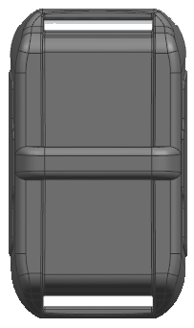
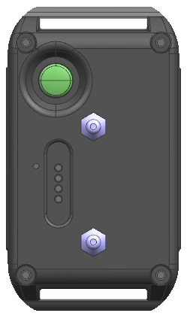

- Power on button

- Speaker/Microphone
- Electronic shock Point

- Charging Point

Start Using
1. Insert a SIM card with 4g data activated.
2. Press the backside circle button 3 seconds to power on, and beep one time.
Press button 6 seconds to power off, and beep one time.
3. Put back back shell and tighten the screws for 100% waterproof
Light | Signal | Normal | Abnormal
Green | GSM | Flashing | Constant on
Blue | GPS | Flashing | Constant on
Red | Power | Constant on: charging | Turn off: charged full
Device will power off automatically during charging.

SMS Command List
SMS Function | SMS Command format |  | SMS example
- Please don’t type “+” “space”, password 123456
- Preset Center Number first before testing SMS or Phone Call alarm mode.
- Each SMS must reply“OK” represent command successfully.
Mode 0 |  | mod123456+space+0 |  | Real time mode consume battery fast
Mode 1 |  | mod123456+space+1 |  | Vibrate mode based on movement
Mode 2 |  | mod123456+space+2 |  | Deeply sleep mode wakeup 3 minutes at every 2hrs
Get location now |  | DM123456 |  | Get current location update 1 time
Find Pet via buzzer |  | Find123456 |  | Buzzer sound 10seconds
Set IP Port |  | adminip+password+space+IP Address+space+port number |  | adminip123456 www.gps2828.com 7018
Set APN |  | apn123456+space+LocalApn+space+ApnName+space+ApnPassword |  | apn123456 internet
Set Time Interval |  | ITV123456+space+time interval(s) |  | If 60s , send SMS: ITV123456 60
Set admin number |  | Admin123456+space+PhoneNumber |  | You can set max 5 numbers  Admin123456 13702581234 13702581235 13702581236
Set low battery alarm |  | lowbat123456+space+on |  | lowbat123456 on
Cancel low battery |  | lowbat123456+space+off |  | lowbat123456 off
Set SMS time zone |  | Time+space+zone123456+space+X |  | If+3,send sms time zone123456 3
Check device status |  | check123456 |  | check GPS GSM status
Activate voice listen |  | Monitor123456
Cancel voice isten |  | Tracker123456
Set alarm mode |  | KC123456+space+0 |  | Cancel alarm
 |  | KC123456+space+1 |  | APP alarm (default)
 |  | KC123456+space+2 |  | APP+SMS alarm
Set factory mode |  | begin123456 |  | It will erase all setting

Real time Tracking Software

Web: www.gps16888.com
Android & IOS APP : toptrace
Default to use IMEI number login, password as 123456.

