Introduction to K6 product specifications

Product images
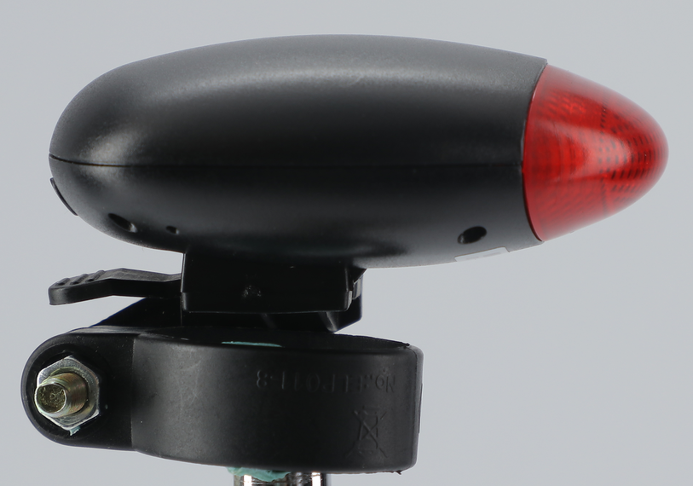

Product Overview
● Product Name: K6-4G Bicycle Locator
● Application scenarios: bicycles, mountain bikes, and other cycling series
● Core functions: real-time positioning, historical track playback, electronic fence, wifi positioning, overspeed alarm, vibration alarm, low battery alarm, etc
● Product Highlights: High-precision positioning (5 meters), four-mode positioning (GPS + Beidou + LBS + WIFI), long battery life, strobe warning lights, and bracket installation
One-click car locator (with buzzer)

Technical Specifications
project | Function Name | have | none | Functional Description
Power Characteristics | power supply method | ● |  | battery-powered
Power Characteristics | Operating voltage range | ● |  | DC 3.45V - 4.35V
Power Characteristics | operating current | ● |  | 3.7V/45mA (GPS upload for one minute)
Power Characteristics | quiescent current | ● |  | 3.7V/4mA
Power Characteristics | Built-in battery capacity | ● |  | 1500 mAh (3.8V polymer battery)
Environmental characteristics | Operating temperature range | ● |  | -20℃ - 70℃
Environmental characteristics | Storage temperature range | ● |  | -40℃ - 85℃
Environmental characteristics | Operating humidity range | ● |  | 5%-95%
Communication characteristics | Communication module brand/chip model | ● |  | ASR1603S
Communication characteristics | communication frequency band | ● |  | GSM：900/1800MHZ  FDD-LTE:B1/3/5/8  TDD-LTE:B38/39/40/41
Communication characteristics | SIM card | ● |  | Nano SIM card
Communication characteristics | communication antenna | ● |  | Built-in FPC antenna
GPS/BD positioning features | Cold start time | ● |  | On average, it takes 45 seconds
GPS/BD positioning features | Hot start time | ● |  | On average, 1 second
GPS/BD positioning features | Sensitivity (tracking) | ● |  | -165dbm
GPS/BD positioning features | positioning antenna | ● |  | Built-in antenna FPC antenna
Hardware function | USB | ● |  | Type-C, charging, activating battery
Hardware function | LED | ● |  | Strobe warning light
Hardware function | buzzer | ● |  | One-click car locating
Hardware function | Gsensor | ● |  | built-in
Hardware function | GPS | ● |  | Support global GPS and Beidou
Hardware function | WiFi | ● |  | WiFi positioning
Outline specifications | Host dimensions (length, width, height) | ● |  | 73mm × 60.5 mm × 29 mm
Outline specifications | Shell material | ● |  | ABS plastic
Outline specifications | IP protection rating | ● |  | IP65
Outline specifications | bicycle stand | ● |  | ABS plastic + silicone gasket
Outline specifications | host weight | ● |  | ~85 grams

Software features
Real-time tracking: View real-time locations through the APP/Web terminal, with update frequencies adjustable in multiple modes (10 seconds to 3 minutes).
Electronic fence: Customize a security zone, and trigger an APP push alert when entering or exiting.
Historical track: Stores and replays movement paths within 180 days, supports exporting in KML/GPX formats.
Multi-account management: Supports family/team sharing of device permissions.
OTA upgrade: Remote wireless firmware upgrade, with continuous optimization of functions.

