AK 2W

quick

quick

make

use

point

south

(Version V3.0)

Please read the installation and usage guide carefully before use to obtain the correct installation method and quick operation instructions. If there are any changes to the appearance and color of the product, please refer to the actual product! If the software content is updated, please refer to the instruction document attached to the latest version of the software. Our company does not assume legal responsibility for any errors or omissions during use.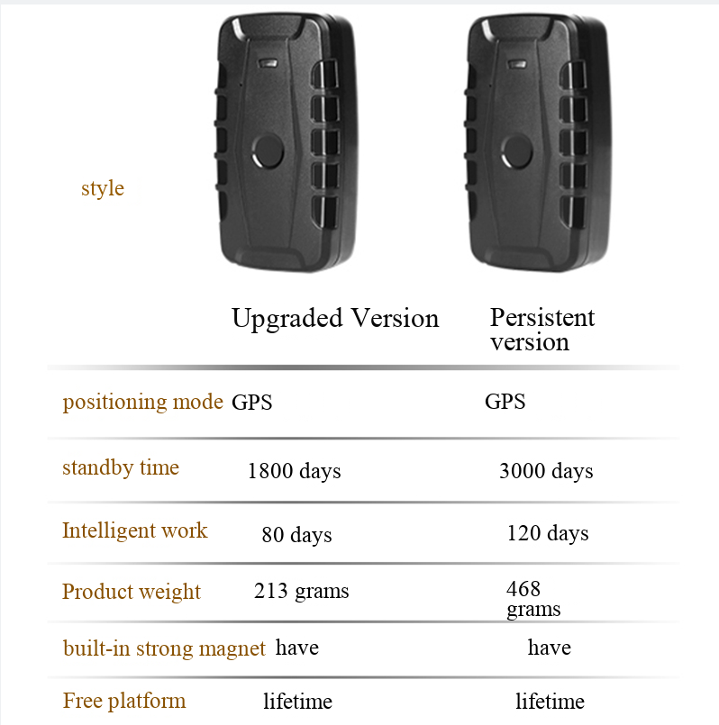

1. Product functional parameters
1.1 Product functions:
Location inquiry, track playback, electronic fence, inflection point supplementary transmission, blind area supplementary transmission, docking report, low battery alarm, overspeed alarm, displacement alarm, etc.

(Note: The functions of different models vary. Please refer to the corresponding model for specific functions.)

1.2. Performance parameters:
●Network standard: 4G, 3G, 2G (optional);
● Charging requirements: 5V DC - 1000mA;
● Positioning time: average warm start: ≤3sec (opensky)
Average cold start: ≤35sec (opensky)
● Positioning accuracy: ≤10 meters (open sky)
● Operating temperature: -20℃-70℃

Important notice: Please install and use the device within its performance capacity. If the illegal installation exceeds the device's performance capacity, the user shall bear all the consequences arising therefrom!

II. Product accessories and LED light status
2.1 Product accessories:
Standard configuration: device/charging cable/quick installation guide

2.2 Terminal LED status
2.2.1 Red LED (power/charging indicator)
The status of the light | meaning
Chang Liang | Charging
Not lit up | Not charged/Fully charged/Off
2.2.2 Yellow LED (network signal status)
The status of the light | meaning
"Shan Shuo" | network initialization
Chang Liang | Network communication is normal
Not lit up | Hibernate/Shutdown
2.2.3 Blue LED (positioning signal status)
The status of the light | meaning
"Shan Shuo" | In the search for positioning signals
Chang Liang | Located
Not lit up | Hibernate/Shutdown

III. Terminal Installation Instructions
Preparations before installation:
Open the packaging box and check whether the equipment model is correct and the accessories are complete. If not, please contact your dealer;
② SIM card selection: The terminal needs to insert a standard SIM card and select a supported operator's SIM card.
③ For the installation of the SIM card, confirm the orientation of the SIM card according to the type of SIM card slot on the device, and place the SIM card correctly.

Note:
(1) Before installing or removing the SIM card, please shut down the terminal first;
(2) The SIM card at the terminal needs to be activated with networking capabilities;
(3) The call pickup function requires the activation of the caller ID display function (depending on the customer's desired functionality, it can be activated or not activated);
(4) If your SIM card has been set to require the input of SIMPIN, please refer to your phone user manual to disable the SIMPIN input function;
(5) Please ensure that the SIM card in the terminal has credit.

IV. Terminal Operation Instructions
4.1 SMS instructions
The user sends a text message command to the SIM card number of the positioning terminal using their mobile phone (note that the SIM card needs to support text messaging).
The comma in the following SMS instruction format represents the English input status format, and the letters are case-sensitive as required by the instruction.
Common query functions | SMS instruction format | Device response
Terminal status query | CXZT | Information such as version, ID, IP, etc
Longitude and latitude link query | G1234 | Google link address
Restart the device | CQ | CQ OK
Restore factory settings | FORMAT | FORMAT OK
Modify APN | APN,123456,cmnet | APN SET OK
Modify APN username | APNUSER,123456,user | APNUSER SET OK
Modify APN password | APNPASSWD,123456,password | APNPASSWD SET OK
Upload time setting | FREQ,123456,30 | FREQ SET OK
Modify server IP and port settings | IP+space+IP address+space+port number  Example: IP 106.3.230.234 8185 | IP SET OK

4.2. Client application operation
Log in to the location service platform:
Users can log in to the global positioning service platform provided by the dealer to view the location and status of the terminal and perform corresponding operations. For the website address of the service platform, please consult your dealer.

1. Method for querying via computer login:
Individual users, please log in using your device ID number, which can be found on the device itself and on the packaging box. When logging into the platform, please select IEIM/ID login. The default password is: 123456!
Enterprise users, please log in with your username. The username and password are set by the distributor. Please contact your respective distributor for allocation!

2. Method for querying via mobile phone APP:
For Android devices, scan the QR code to download the app; for Apple devices, search for the app name in the Apple App Store to download.
Individual users, please log in using the device ID number, which can be found on the device itself and on the packaging box. When logging into the platform, please select IEIM/ID login. The default password is: 123456!
Enterprise users, please select a username to log in. The username and password are set by the distributor. Please contact your respective distributor for allocation!

V. Troubleshooting
When operating the terminal, if you find that the device is not working properly, please refer to the following problems and solutions; if the issue persists, please contact the dealer.

Frequently Asked Questions | Problem occurred | solution
Poor signal reception | In areas with poor reception, such as near high-rise buildings or underground parking lots, radio waves cannot be effectively transmitted | Use the terminal in a location with good signal
First-time installation platform display  Not enabled | The SIM card is not properly installed | Install the SIM card correctly
First-time installation platform display  Not enabled | The indicator light is not on. | Charge the battery
First-time installation platform display  Not enabled | The indicator light is flashing. | Check SIM card status
First-time installation platform display  Not enabled | The SIM card has not been activated with GPRS function | Please contact the service provider to activate GPRS
Platform map display  The position is incorrect | GPS not located | Please proceed to an open area outdoors for positioning
Platform map display  The position is incorrect | The terminal has been stationary since it was installed | Take the terminal outside and run it around a few times
The platform displays an offline status | The SIM card is in arrears or GPRS has been cancelled | Please check the SIM card status
The platform displays an offline status | The signal in the offline area is weak | Please try again in a place with strong signal

Warranty Card
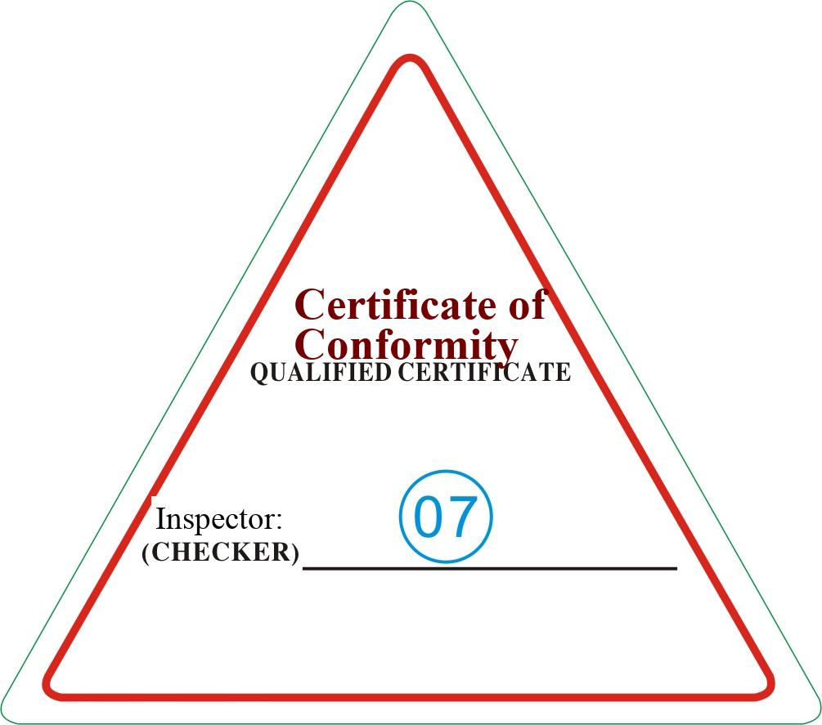
Special Statement:
- If there are any technical changes to this product in the future, no further notice will be given.
- If there are any changes in product appearance and color, please refer to the actual product.
- The warranty card is only applicable to the three-guarantee services for the devices with the IMEI numbers listed below.
- Please keep this repair card properly and present it along with the original purchase receipt during warranty service.
- Please refer to the table below for specific warranty coverage.

This card serves as the basic proof of warranty. Please fill it out carefully and keep it properly.
User Name |  | Contact number
Mailing Address
Product Model |  | IMEI number
Purchase date |  | Invoice Number
Name of sales unit
Sales unit address
Sales unit phone number
- From the date of purchase, the product is covered by a one-year warranty for non-human-induced damage or malfunction;
- If it falls under any of the following circumstances, it is not covered by the warranty, but can be repaired for a fee;
- The warranty period has expired;
- Damage caused by unauthorized disassembly or repair without authorization from our company;
- Immersed in water, the circuit board was burned;
- Damage caused by improper installation, use, maintenance, or storage;
- Damage to the product casing caused during use;
- The IMEI number inside the product has been removed or is illegible;
- The warranty certificate does not match the product model or the warranty certificate has been altered;
- Damage caused by force majeure.

