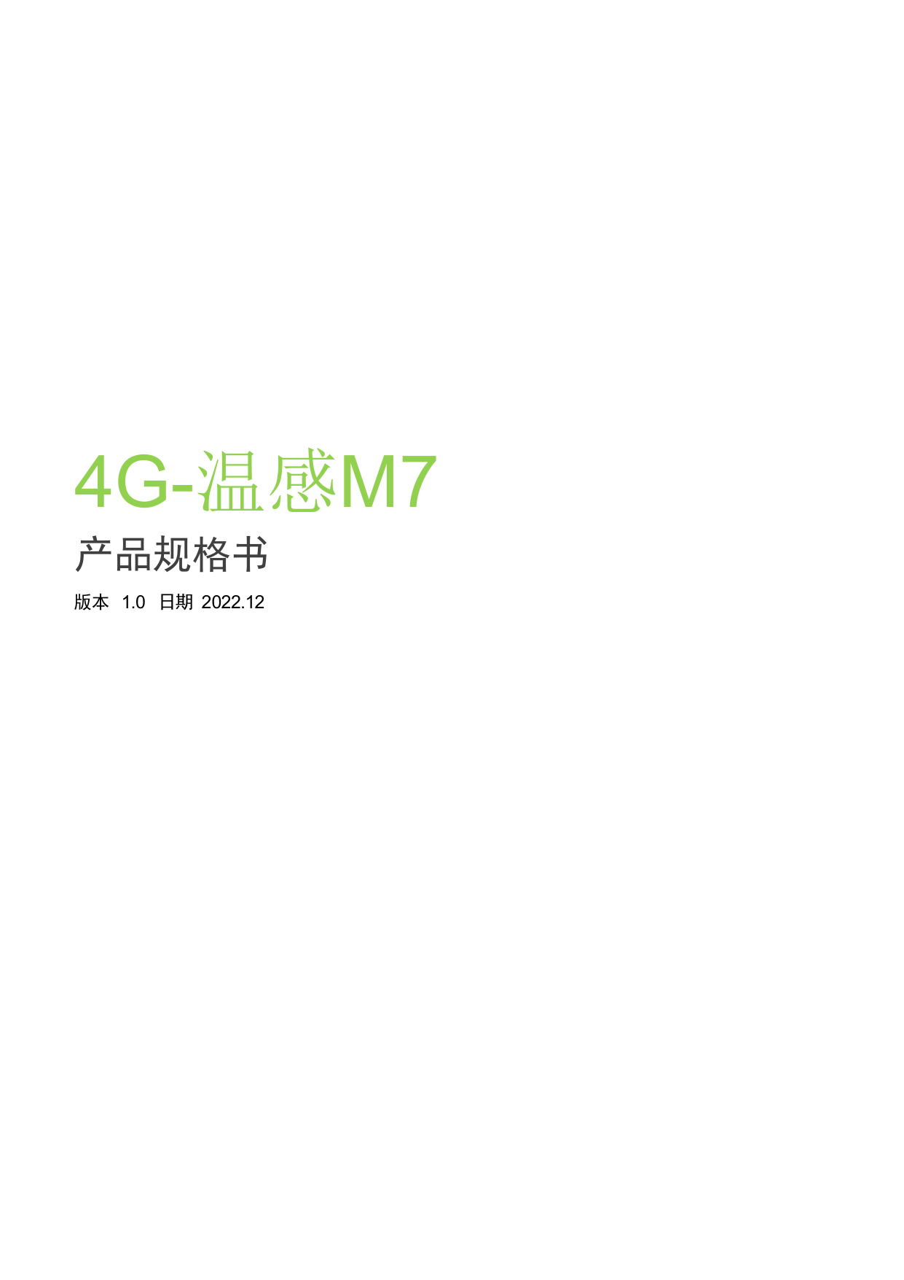
4G-Temperature Sensing M7
Product Specification
Version 1.0, dated 2022.12

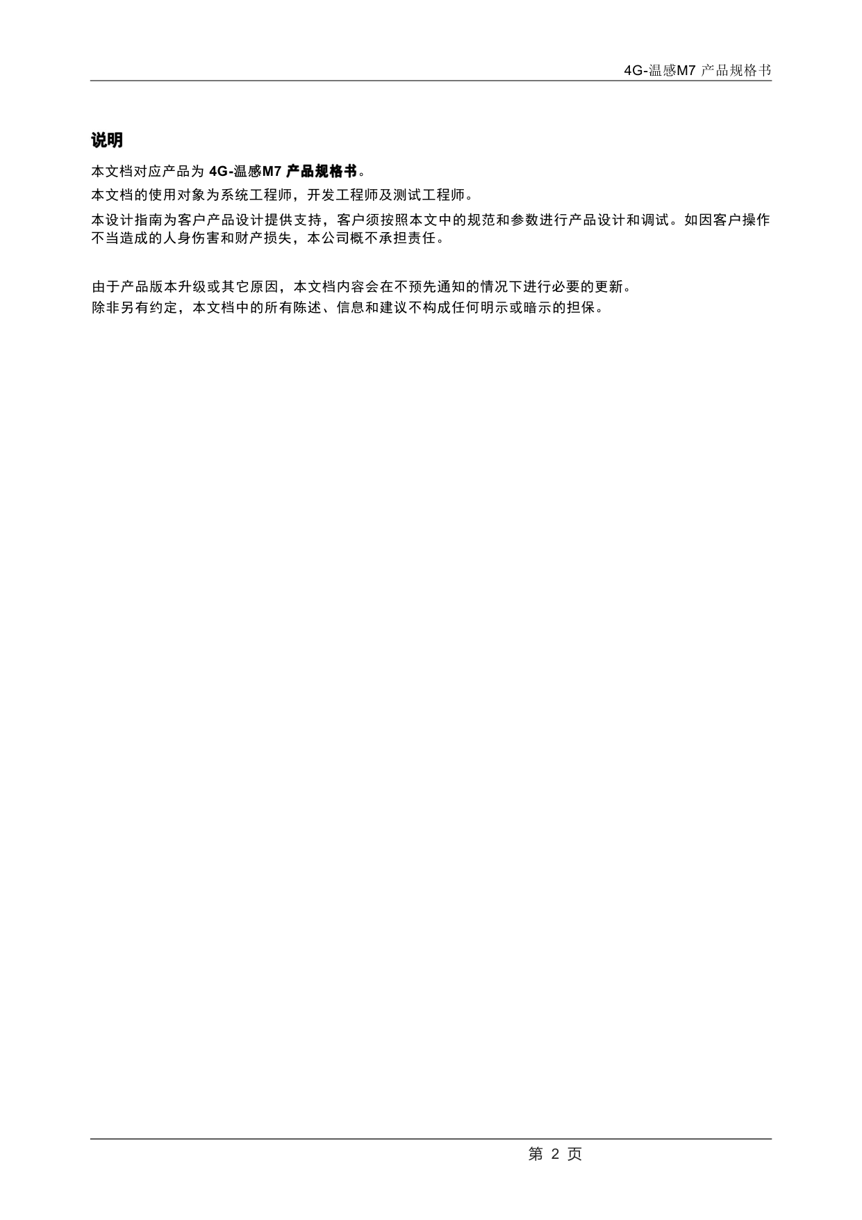
4G-Temperature Sensing M7 Product Specification
Instructions
The corresponding product of this document is the 4G-temperature sensing M7 product specification
This document is intended for system engineers, development engineers, and test engineers
This design guide provides support for customer product design. Customers must conduct product design and debugging in accordance with the specifications and parameters outlined in this document. The company shall not be liable for any personal injury or property damage caused by improper operation by the customer
Due to product version upgrades or other reasons, the content of this document may undergo necessary updates without prior notice
Unless otherwise agreed, all statements, information, and recommendations in this document do not constitute any express or implied warranties

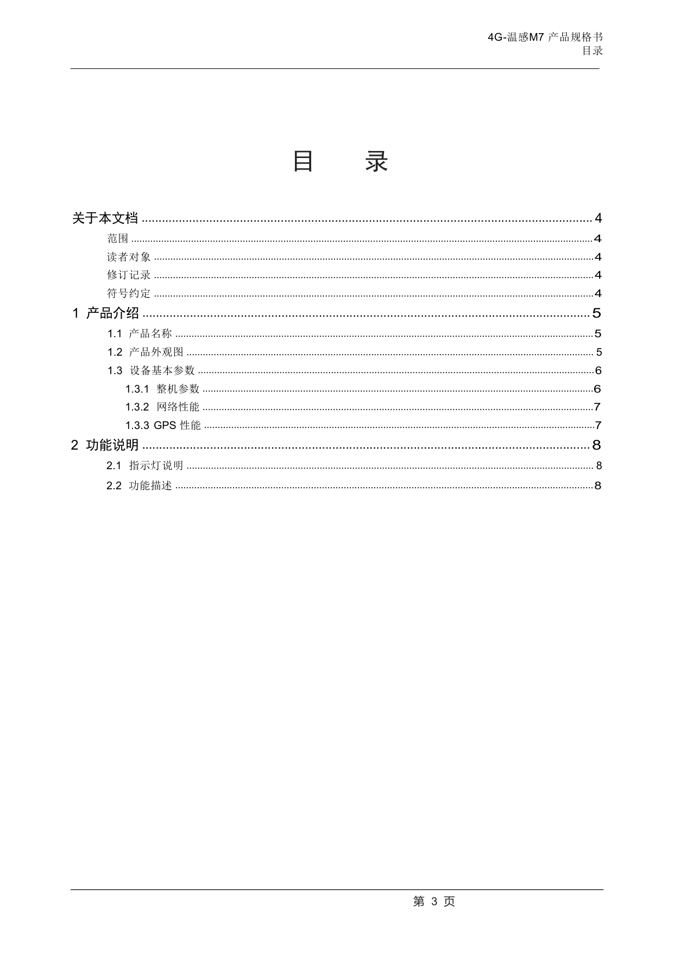
4G-Temperature Sensing M7 Product Specification
catalogue
catalogue
.....................................
......................
......
.......................
...................................
1.............................
1.........
1...............................
1.........
.....
...................
..................
2................................
..............
..........

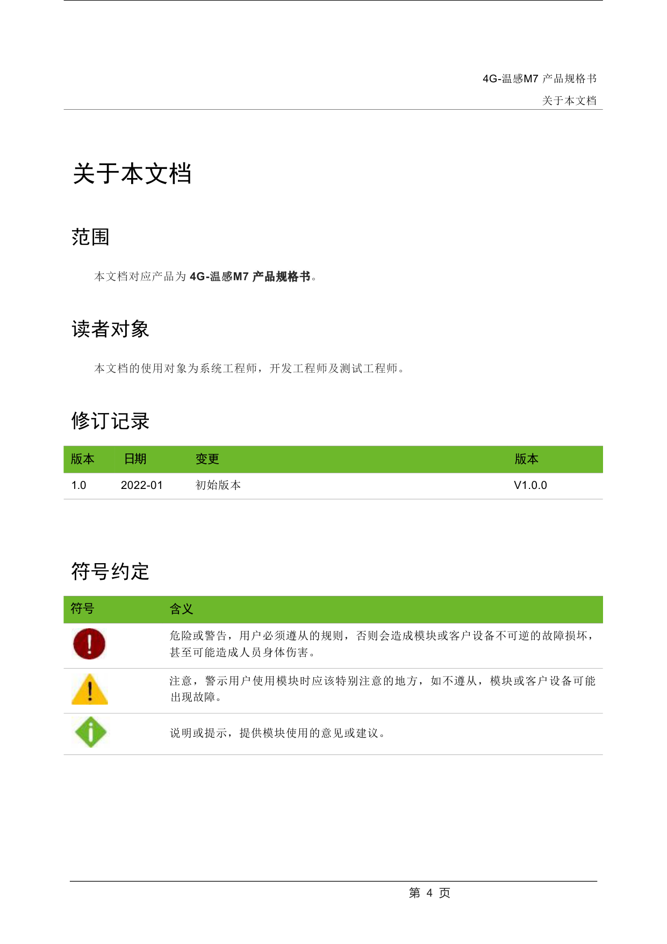
4G-Temperature Sensing M7 Product Specification About this Document
Regarding this document
scope
The product corresponding to this document is the 4G-temperature sensing M7 product specification
Target audience
This document is intended for system engineers, development engineers, and test engineers
Revision History

Symbol convention
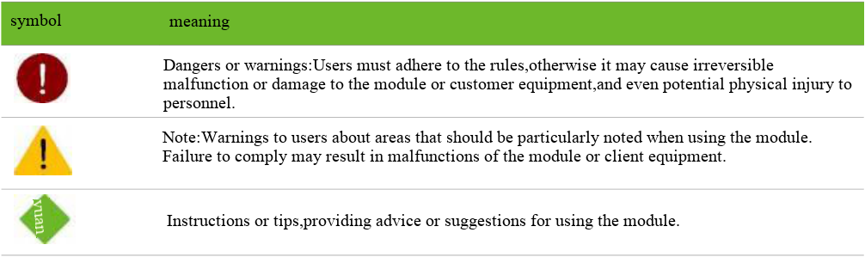

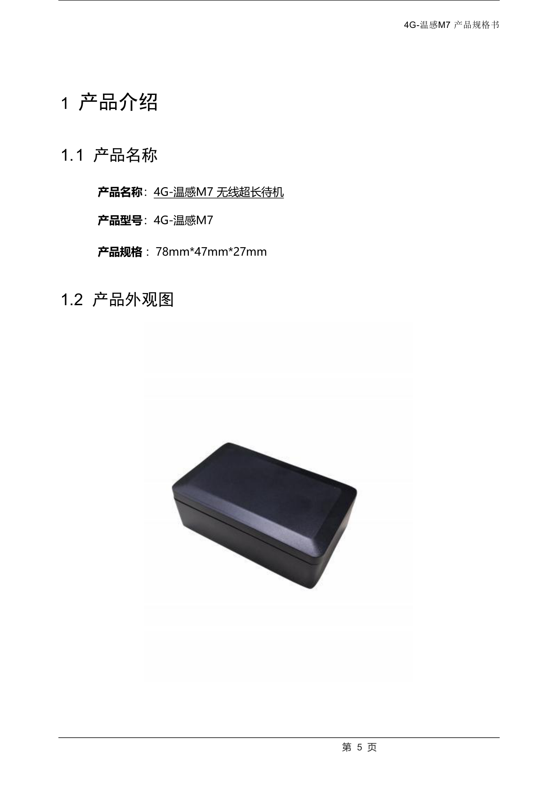
4G-Temperature Sensing M7 Product Specification
1 Product Introduction
1.1 Product name
Product Name: 4G-Temperature Sensing M7 Wireless Long Standby
Product model: 4G-Temperature Sensor M7
Product specification: 7
1.2 Product appearance drawing
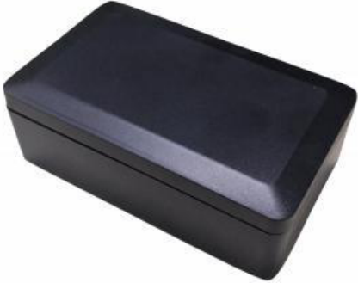
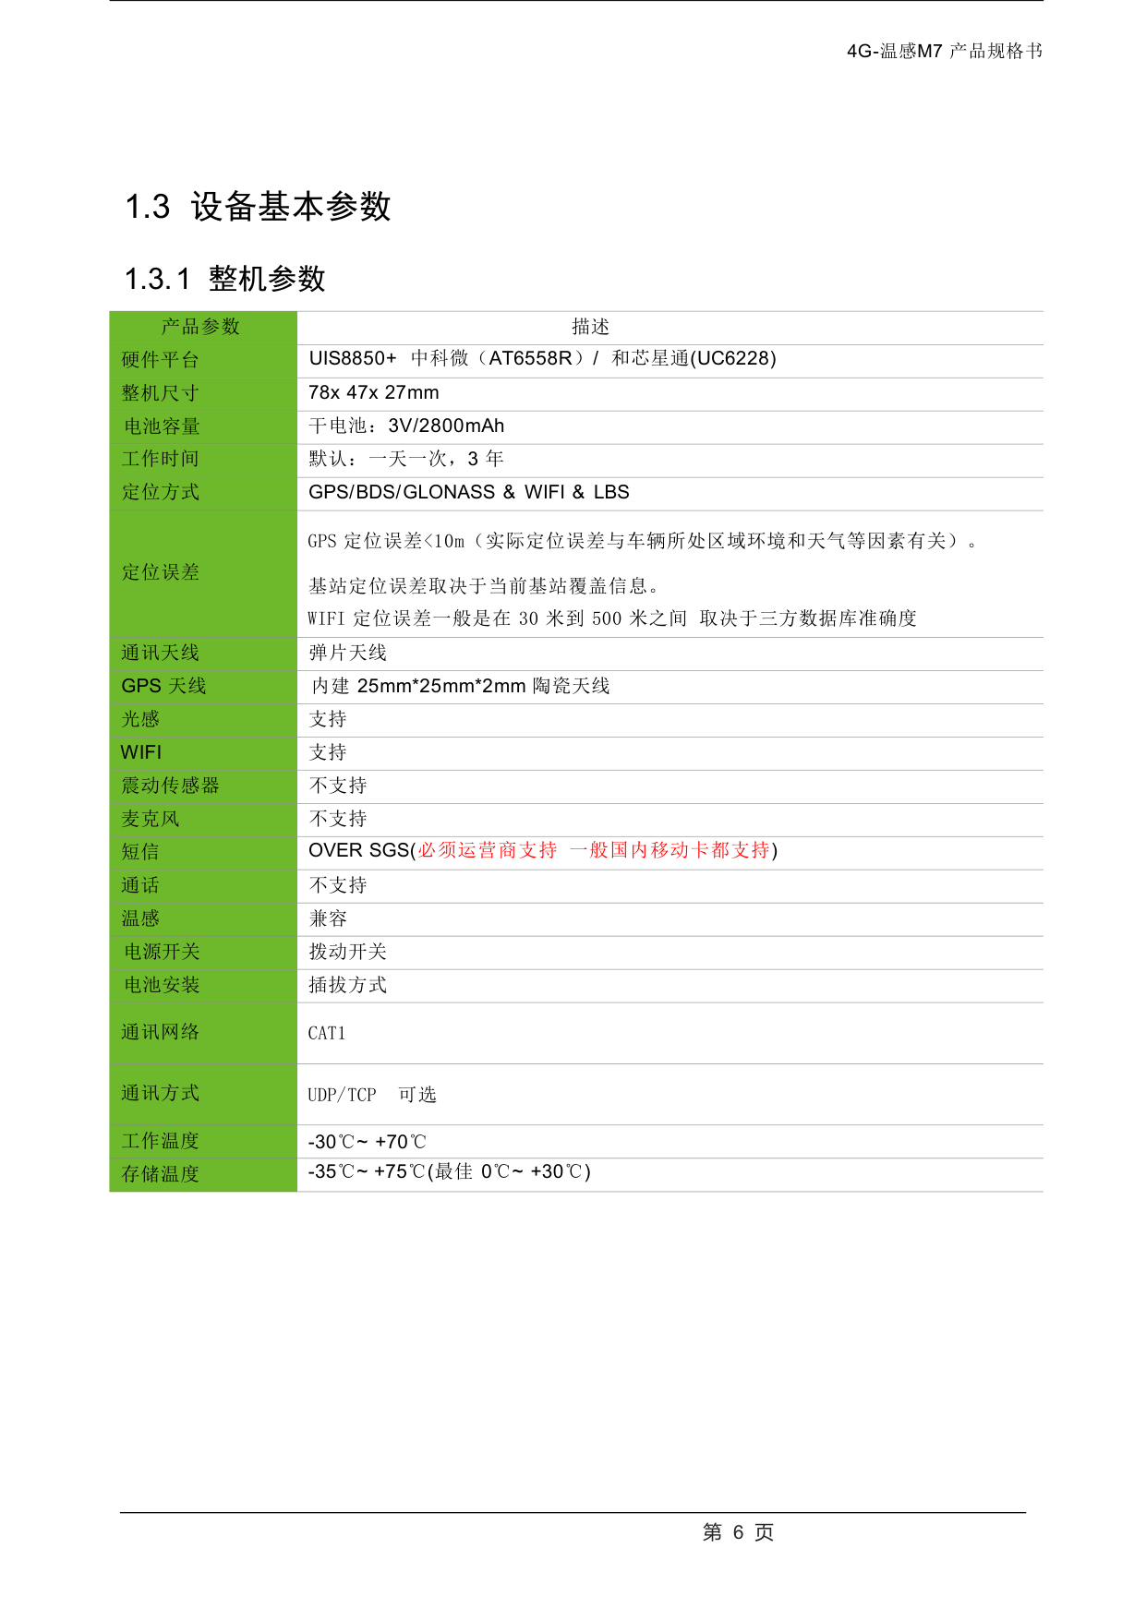
4G-Temperature Sensing M7 Product Specification
1.3 Basic equipment parameters
1.3.1 Overall parameters
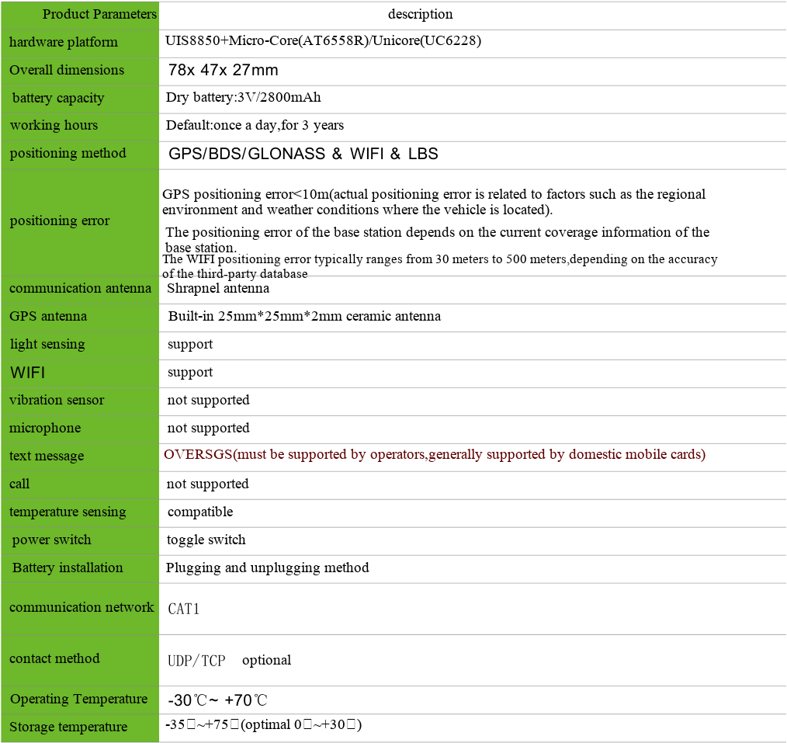

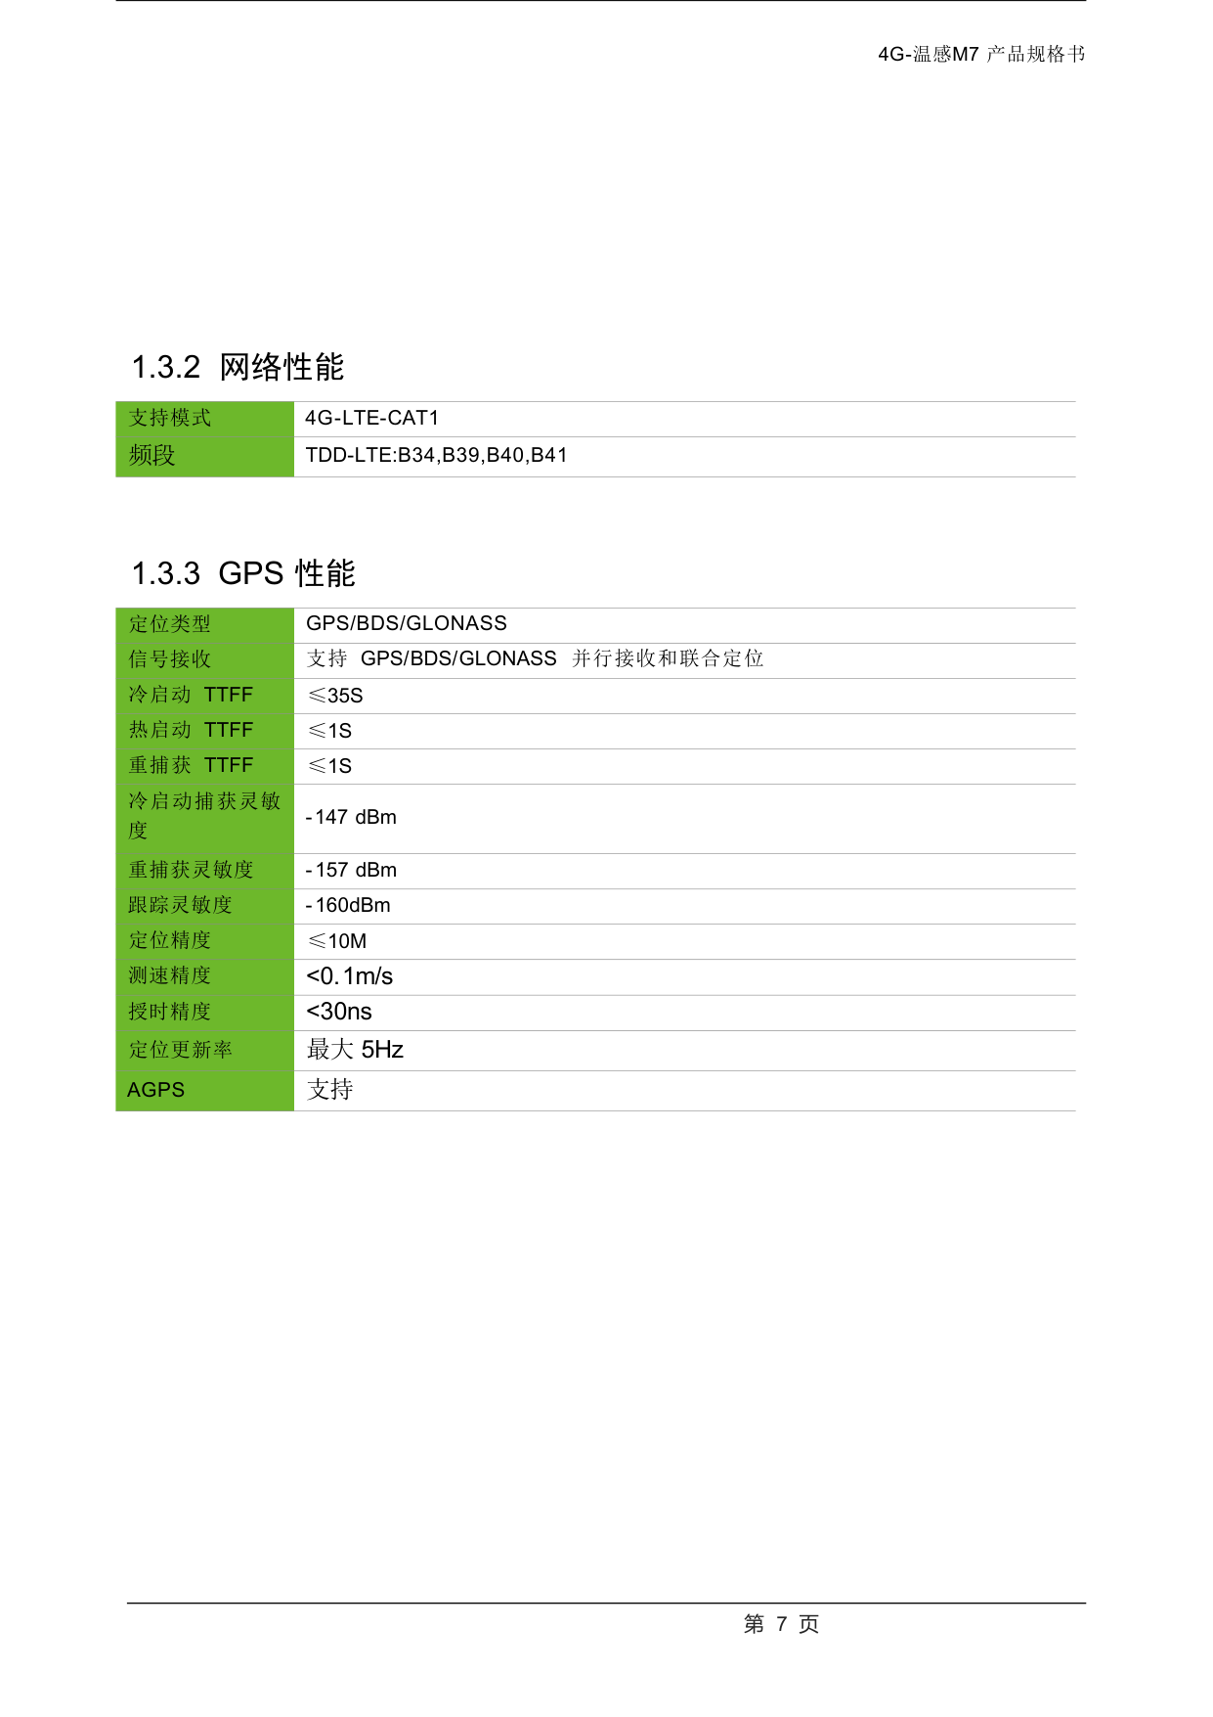
4G-Temperature Sensing M7 Product Specification
1.3.2 Network performance
1.3.3 GPS performance
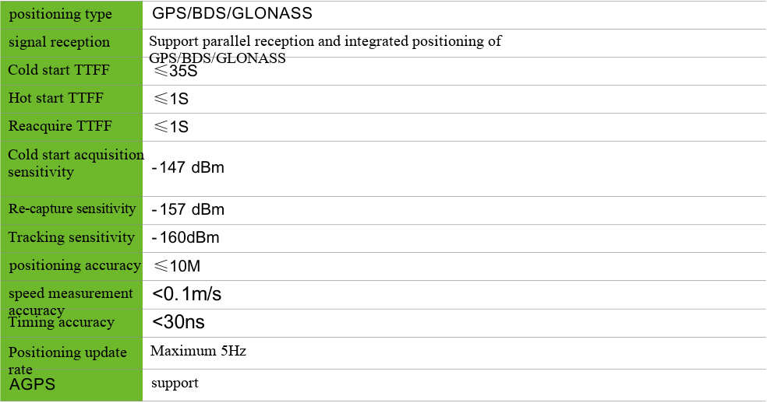

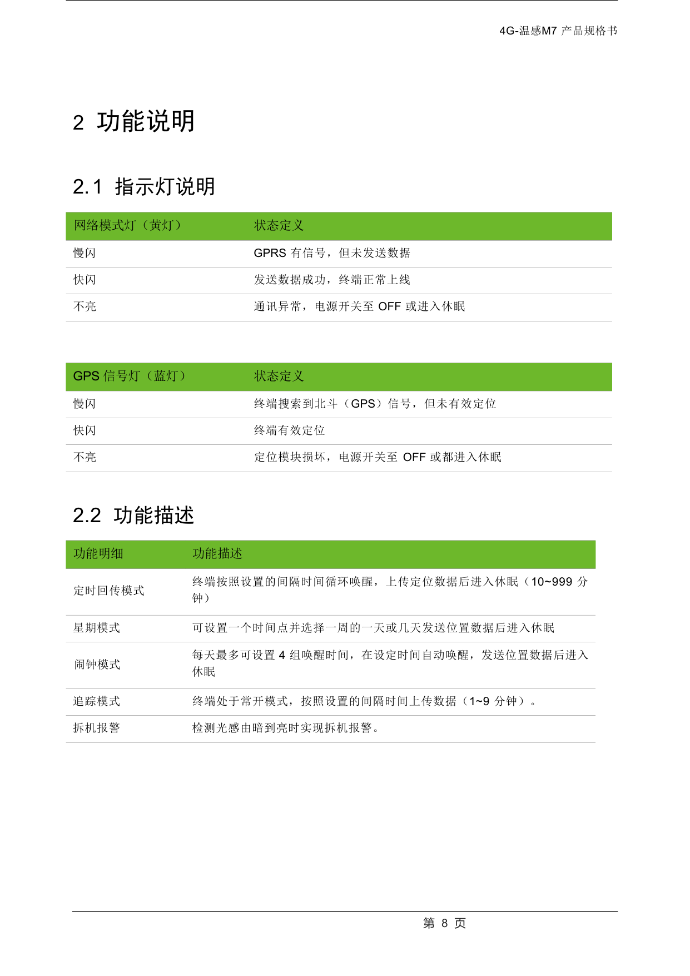
4G-Temperature Sensing M7 Product Specification
2 Function description
2.1 Indicator light description
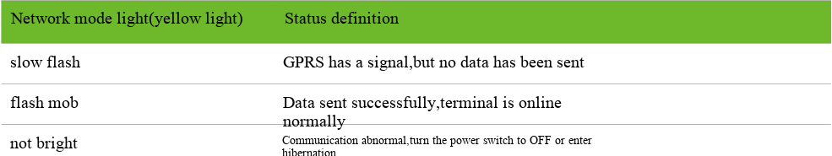
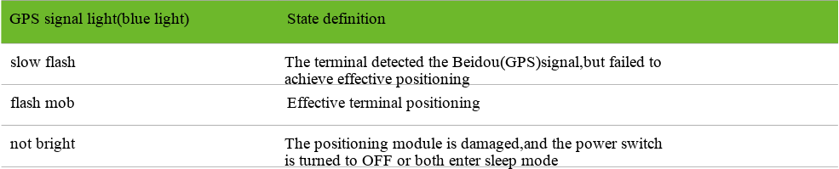
2.2 Function Description
