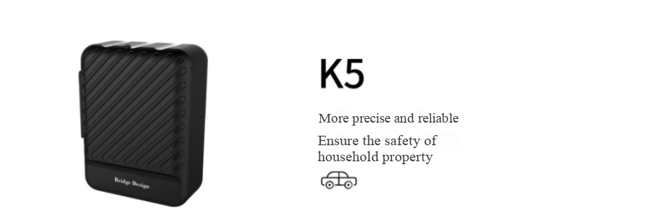

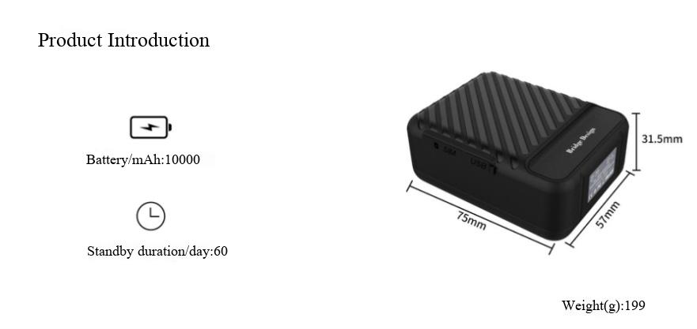

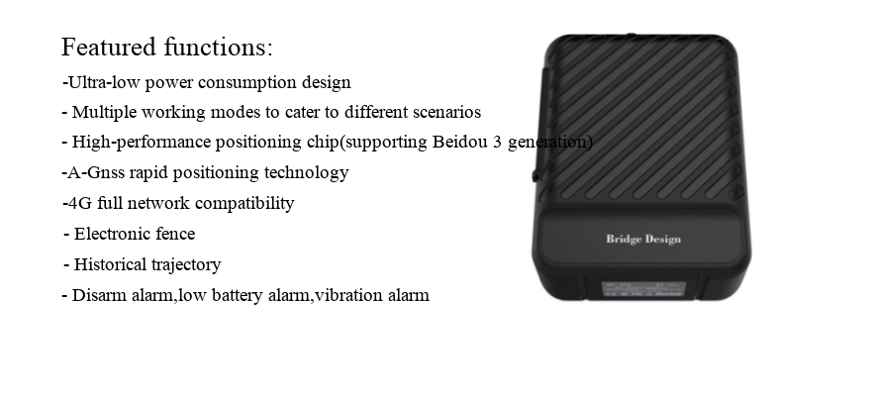

Product images

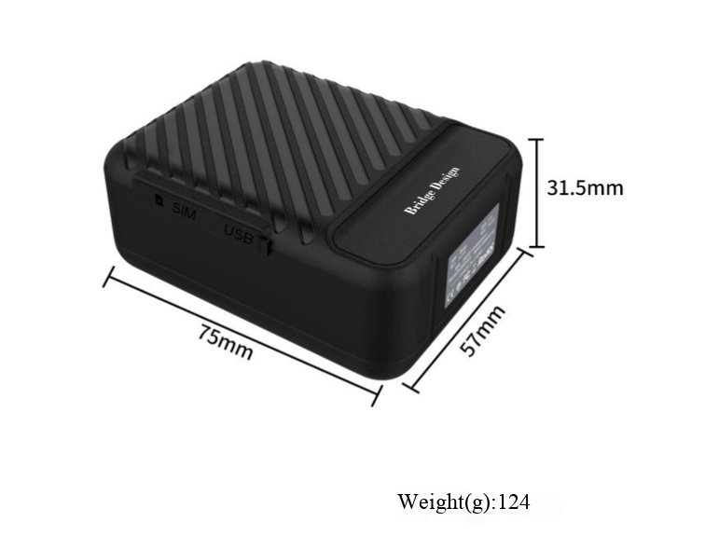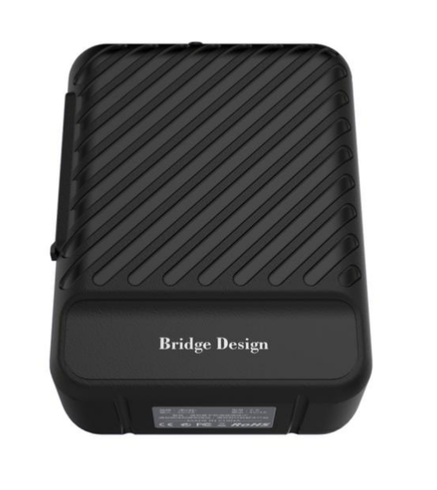

Detailed specifications:
- Precise positioning, with an accuracy of 1.5 meters (the product supports Beidou III).
- GPS + Beidou + LBS + WIFI four-mode positioning.
- Practical functions: real-time positioning, latent positioning, vibration wake-up, and step counting positioning.
- Dismantling alarm, vibration alarm, displacement alarm, low battery alarm, fence exit alarm, overspeed alarm, etc.
- Small in size, easy to conceal, with strong magnetic attraction (optional).
Application fields:
Leased vehicles, credit vehicles, passenger vehicles, taxis, freight vehicles, cattle and sheep positioning management, valuables management, etc

Device parameters:
project | Function Name | have | none | Functional Description
Electrical Characteristics | power supply method | ● |  | battery-powered
Electrical Characteristics | Operating voltage range | ● |  | DC 3.45V - 4.35V
Electrical Characteristics | operating current | ● |  | 22mA
Electrical Characteristics | Standby current | ● |  | About 30uA
Electrical Characteristics | Online standby current | ● |  | 4.5mA
Electrical Characteristics | Built-in battery capacity | ● |  | 10000mAh (3.8V polymer battery)
Environmental characteristics | Operating temperature range | ● |  | -20℃ - 70℃
Environmental characteristics | Storage temperature range | ● |  | -30℃ - 80℃
Environmental characteristics | Operating humidity range | ● |  | 5%-95%
Communication characteristics | Communication module brand/chip model | ● |  | ML307A-DCLN-China Mobile IoT
Communication characteristics | communication frequency band | ● |  | TDD:B34/38/39/40/41,FDD:B1/3/5/8
Communication characteristics | SIM card | ● |  | Micro SIM card
Communication characteristics | communication antenna | ● |  | Built-in FPC antenna
GPS/BD positioning features | Positioning module brand/chip model | ● |  | BGI GPS Beidou chip (supporting Beidou-3)
GPS/BD positioning features | Cold start time | ● |  | Average 32 seconds
GPS/BD positioning features | Hot start time | ● |  | Average: 1 second
GPS/BD positioning features | Sensitivity (tracking) | ● |  | -162dBm
GPS/BD positioning features | positioning antenna | ● |  | Built-in active ceramic GPS antenna
external interface | Loudspeaker output interface |  | ●
external interface | I/O interface |  | ●
external interface | ADC detection input interface |  | ●
external interface | RS485 interface |  | ●
external interface | RS232 interface |  | ●
external interface | serial port | ● |  | 3.3V serial port channel 1
external interface | CAN |  | ●
external interface | K-line |  | ●
Outline specification | Host dimensions (length, width, height) | ● |  | 75mm × 57 mm × 31.5 mm
Outline specification | Shell material | ● |  | ABS plastic
Outline specification | IP protection rating | ● |  | IP65
Outline specification | strong magnet | ● |  | optional
Outline specification | collar | ● |  | optional
Outline specification | host weight | ● |  | About 199 grams

