NY Solar Product Specifications
project | description
product image | 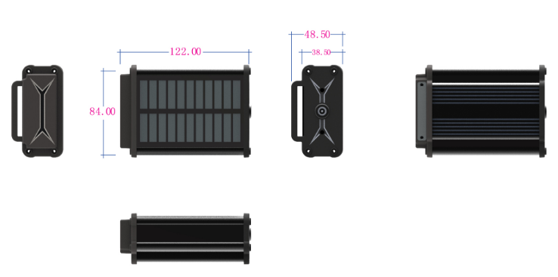
Product Name | NY high-capacity positioning | Supports TDD/FDD/GSM mobile network access services, GPS positioning, Beidou positioning, and WIFI positioning
structural characteristics | Overall dimensions | 122*84*48.5mm
structural characteristics | Unit Weight | 400g/551g
data services | FDD/TDD | Upstream rate of 5Mbps, downstream rate of 10Mbps
data services | GSM | The upstream rate is 48kbps, and the downstream rate is 54kbps
Communication network frequency band | Full Netcom | China Mobile, China Unicom, China Telecom
Communication network frequency band | FDD frequency band | B1,3,5,8
Communication network frequency band | TDD frequency band | B38,39,40,41
Communication network frequency band | GSM frequency band | 900/1800MhZ
GPS frequency band | Beidou | 1561.098MHz
GPS frequency band | GPS | 1575.42MHz
GPS sensitivity | Acquisition | -148dBm(cold)/-163dBm(hot)
GPS sensitivity | Tracking (tracking) | -165dBM
GPS sensitivity | power consumption | Acq:37mW,Tracking:27mW
WIFI function | support | Obtain MAC address, save power
Power Characteristics | Working Voltage | 3.5-4.2V DC
Power Characteristics | voltage fluctuation | 3.3-4.5V DC
Power Characteristics | operating current | Sleep 0.3mA (maintaining clock) Standby 3.3mA (3-minute heartbeat)  Positioning 60mA (LTE+GPS)
Power Characteristics | Built-in battery | 10000mAh/20000mAh
Environmental characteristics | Operating Temperature | -20℃～+70℃
Environmental characteristics | Ultimate operating temperature | -30℃～+75℃
Environmental characteristics | Storage temperature | -40℃～+85℃
Environmental characteristics | relative humidity | 5%～95%
Main hardware functions | Gsensor | built-in
Main hardware functions | GPS | Support global GPS and Beidou
Main hardware functions | solar energy
Main hardware functions | LED indicator light | GPS (blue), GSM (green), Power (red)
Main hardware functions | SIM interface | Nano, push-push side insertion, compatible with 5*6 ESIM
Main hardware functions | USB | Type-C, charging + downloading, testing, activating battery
Main hardware functions | Simulated voice | Built-in dual microphones (interruption detection + recording)
Main hardware functions | watchdog | Support, built-in chip
Main hardware functions | antenna | GPS: Passive dual-mode ceramic 18*18; LTE: FPC (with spring clips on the mainboard)  WIFI: FPC (mainboard with spring clip)
Main software functions | Smart wake-up/sleep | Support, timing or Gsensor
Main software functions | positioning | Support, scheduled positioning, intelligent positioning, super power-saving positioning
Main software functions | WIFI positioning | support
Main software functions | Anti-theft recording | support
Main software functions | FOTA | support

