Product Name: | GPS positioning terminal
Product Model: | C003F
File Version: | V1.0
Version Date: | 2025.08.17

version | Updated content | Reviser | Time of revision
V1.0 | Function description, specifications | Cheng Xin | 2025.08.17

directory
1. Basic introduction of the product 3
1.1 Product Introduction 3
1. Fields of application 3
1.3 Product images 3
1.4 Introduction to the use of the product 4
1.4.1 SIM Card mounting method 4
1.4.2 Indicator light description 4
1.4.3 Working logic 4
2. Features 5
3. Product parameters 6
Hardware specifications 6

- Basic introduction of the product

1.1 Product Introduction
C003F is a 4G full Netcom vehicle positioning terminal carefully built for the Internet of Vehicles, integrating 4G full Netcom wireless communication technology and GPS/BDS satellite navigation and positioning technology, the terminal adopts industrial-grade high-integration fully built-in antenna design, the device has a built-in 3-axis sensor, and the intelligent power-saving wake-up work. It has the functions of DC detection, ACC detection, vibration alarm, power failure alarm, overspeed alarm, SOS emergency distress, illegal start alarm and so on. With the global positioning service platform, it realizes the real-time acquisition, tracking and positioning function of vehicle data.

1.2 Application fields
Insurance industry, enterprise fleet industry, automobile manufacturers/4S stores, individual users, electric new energy field, passenger vehicles, taxis, rental vehicles, etc.

1.3 Product Pictures

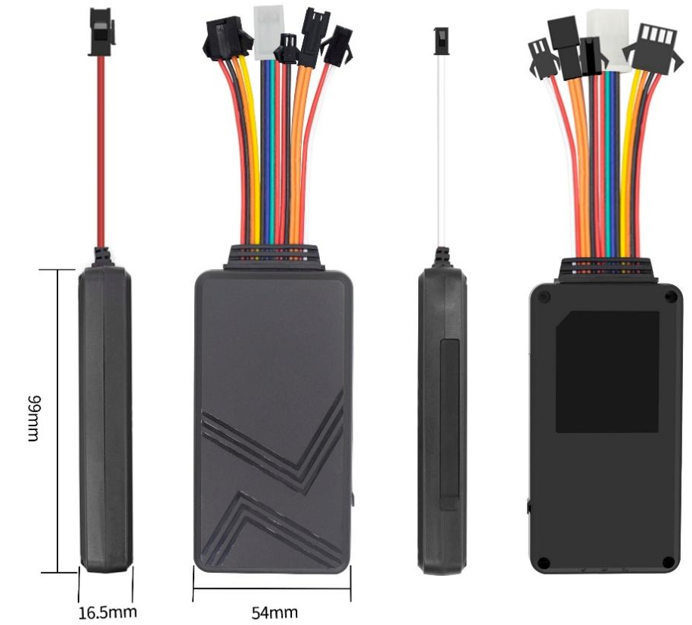

1.4 Introduction to the use of the product

1.4.1 SIM card installation
The device uses a standard SIM card. The card slot is a self-elastic card slot, the chip side is placed away from the label side, and the card notch is inserted into the card slot inward.

1.4.2 Indicator Description
Red Light - Power Indicator
The state of the lamp | meaning
Solid on | work
Not lit | Shutdown
Yellow Light - GSM indicator
The state of the lamp | meaning
Flash 1 time in 2 seconds | GSM initialization
Solid on | GSM communication is normal
Not lit | GSM hibernation/shutdown
Blue light - GPS indicator
The state of the lamp | meaning
Flash 1 time in 2 seconds | Satellite signal searching
Solid on | GPS/BDS has been located
Not lit | GPS/BDS hibernation

1.4.3 Working logic
After the equipment is installed, the yellow and blue lights are always on, and the equipment enters the normal working state.
Static flame-out state: ACC off, the device has one data every 5 minutes.
Motion ignition status: ACC on, the device has a data every 10 seconds.
Vibration alarm: After the fortification, the vibration device will trigger the vibration alarm, and the vibration alarm will be sent to the server after the vibration alarm is triggered If the alarm data is triggered again, it needs to be continuously static for 5 minutes before the alarm can be triggered.
Displacement alarm: If the device is positioned and the device is positioned, the displacement alarm distance is set, and the equipment travels beyond the distance of the line segment It will report a displacement alarm, and the equipment will automatically disarm after the alarm.

Power-off alarm: After the device is connected to the power supply, the device will judge the access to the power supply, and when the device is disconnected from the power supply for 3 seconds, the device Trigger a power-off alarm and upload it to the server.

Illegal start alarm: After turning on the illegal start alarm, when the equipment is fortified and ignited in the state of non-disarming, the equipment will be Report the illegal start of the alarm. (ACC must be connected correctly)
SOS alarm: The device has an external SOS button, press and hold the button for 3 seconds to trigger the alarm, and after the alarm is triggered, the device will be served The server sends an emergency alarm. If the device is set with an SOS number, the device will go to the main control The number sends a distress message and calls the set family number.

- Features:
- STM's advanced 32-bit high-performance MCU processor;
- The hardware can be equipped with 232/485 interfaces, which can be connected to external cameras, oil rods, RFID and other peripheral products to realize intelligent application Internet of Vehicles, Internet of Things monitoring, control, etc.;
- Support multiple alarm functions such as vibration alarm, power failure alarm, overspeed alarm, SOS emergency distress, illegal start alarm, etc.;
- It can be externally connected to the oil-cut electric relay/wireless oil-cut accessories, which supports the function of cutting off the oil circuit/circuit of the monitoring object, and realizes the functions of oil-off electricity;
- Support the electronic fence function, the user delineates the virtual electronic fence through the platform/APP, and the platform can identify and issue an alarm when the equipment enters and exits the fence;
- When an alarm occurs, it can send an alarm SMS/phone call to the guardian number, and the alarm is uploaded to the platform at the same time;
- The terminal adopts industrial-grade high-stability GPRS module from well-known manufacturers, built-in GSM high-sensitivity antenna, supports TCP/IP data transmission, and supports domain name/IP address connection to the server;
- Built-in large-capacity memory chip, support offline data storage, blind area data retransmission;When the vehicle is in a place where the wireless signal is weak or the interference is serious, the car will temporarily store the data of the vehicle operation in the FLASH, and when the wireless signal returns to normal, the data can be supplemented to achieve no data omission. ；
- Built-in 3-axis acceleration sensor, fusion of accurate acceleration algorithm, real-time acquisition of vehicle current attitude and other vehicle condition judgment;
- High-sensitivity GPS/BDS dual-satellite positioning module, anti-interference ceramic antenna, to achieve more stable satellite search signal, support AGPS fast positioning tracking, synchronous timing;
- In sleep mode, it supports automatic reporting of vehicle start-up, flame-off, and dormant such as battery low-voltage monitoring alarm and abnormal vibration alarm;
- Support online remote upgrade and remote configuration of product parameters.
- Low-power energy-saving mode, accurate judgment of the ignition and shutdown status of the car, intelligent sleep and wake-up mechanism, can reduce the average power consumption of the whole system;
Product parameters

3.1 Hardware Specifications
 | The name of the feature | Yes | not | Description of the project's functionality
Electrical characteristics | Power supply mode | ● |  | Battery-powered
Electrical characteristics | Operating voltage range | ● |  | DC 9V - 95V
Electrical characteristics | Operating current | ● |  | 12V/55mA
Electrical characteristics | Sleep current | ● |  | 12V/15mA
Electrical characteristics | Built-in battery capacity | ● |  | 180 mAh (3.7V polymer battery) Optional
Environmental characteristics | Operating temperature range | ● |  | -20℃ - 75℃
Environmental characteristics | Storage temperature range | ● |  | -30℃ - 80℃
Environmental characteristics | Operating humidity range | ● |  | 10%-85% RH non-condensing
Communication characteristics | Communication module brand/chip model | ● |  | SIMCOM A7670SA
Communication characteristics | Communication frequency bands | ● |  | LTE/4G | LTE-FDD:  B1/B2/B3/B4/B5/B7/B8/B28/B66
 |  |  |  | GSM/2G | 850/900/1800/1900MHz
Communication characteristics | SIM card | ● |  | Standard SIM card
Communication characteristics | Communication antennas | ● |  | Built-in antenna
Communication characteristics | Antenna specifications | ● |  | FPC antenna
GPS/BD positioning features | Locate the module brand/chip model | ● |  | Zhongke Micro AT6558R
GPS/BD positioning features | Targeting method | ● |  | Beidou + GPS
GPS/BD positioning features | Cold start time | ● |  | An average of 32 seconds
GPS/BD positioning features | Hot start time | ● |  | An average of 1 second
GPS/BD positioning features | Tracking sensitivity | ● |  | -162 dBm
GPS/BD positioning features | Capture sensitivity |  |  | -148 dBm
GPS/BD positioning features | Locate the antenna | ● |  | Built-in antenna
GPS/BD positioning features | Antenna specifications | ● |  | 25mm * 25mm * 4mm
GPS/BD positioning features | GPS bands | ● |  | L1: 1575.42±1.023MHz
GPS/BD positioning features | Beidou frequency band | ● |  | B1: 1561.098±2.046MHz
GPS/BD positioning features | Number of satellite channels | ● |  | 64
GPS/BD positioning features | Positioning accuracy | ● |  | <10m(1σ)
GPS/BD positioning features | Timing accuracy | ● |  | <30ns（1σ）
GPS/BD positioning features | Speed measurement accuracy | ● |  | <0.1m/s（1σ）
GPS/BD positioning features | Maximum acceleration | ● |  | 4g
GPS/BD positioning features | Maximum speed | ● |  | 515m/s
GPS/BD positioning features | Maximum height | ● |  | 18000m
External interfaces | Cut off oil and electricity | ● |  | It can be connected to an external relay
External interfaces | SOS | ● |  | One external SOS button (optional)
External interfaces | ACC Detection Input | ● |  | ACC detection port all the way
External interfaces | RS232/RS485/TTL (יהוה) | ● |  | RS232/RS485/TTL detection serial port compatible with one (default TTL)
Form factor | Dimensions of the main unit (length, width and height) | ● |  | 99mm * 54mm * 16.5mm
Form factor | Housing material | ● |  | ABS plastic
Form factor | IP rating |  | ●
Form factor | Weight of the main unit | ● |  | 81 g

