Q8 Elderly Locator Product Specification
 | 
 | 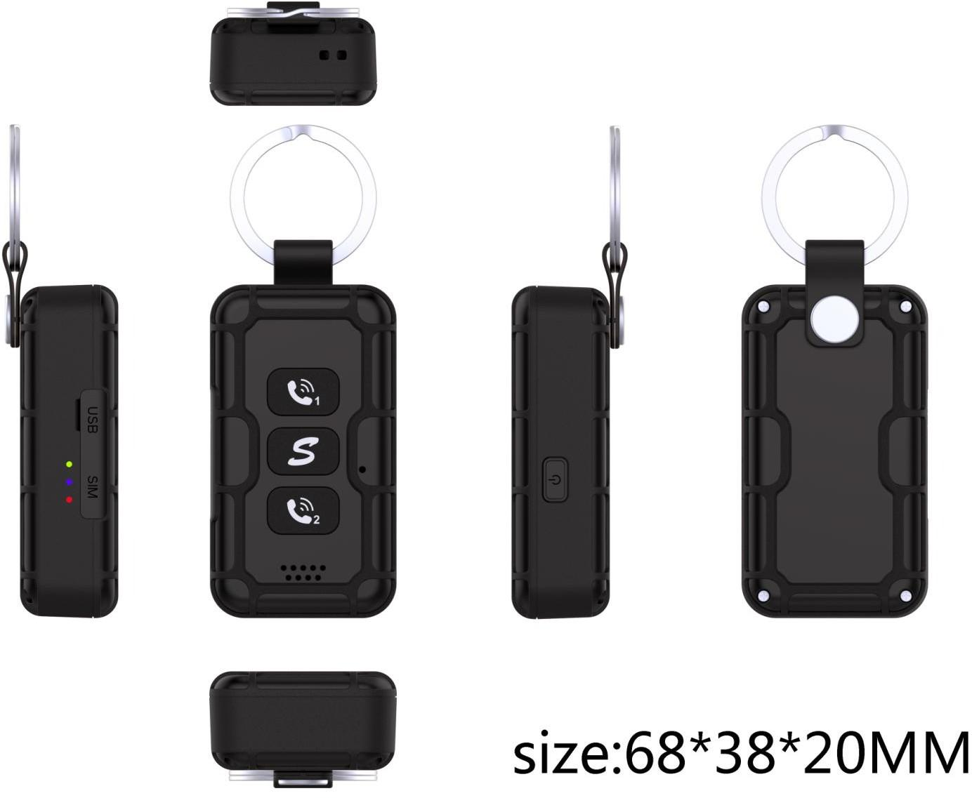
 | Elderly care tracker | Supports TDD/FDD/GSM mobile network access services, GPS positioning, Beidou positioning, and WIFI positioning
 | Overall dimensions | 68*38*20 mm
 | button | Option 1: Power button (compatible with SOS function)  Option 2: Customized buttons for BTB connector: including power button, LED indicator, on/off switch, SOS, and others
 | FDD/TDD | The upstream rate is 5Mbps, and the downstream rate is 10Mbps
 | GSM | The upstream rate is 48kbps, and the downstream rate is 54kbps
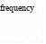 | B1,3,5,8
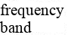 | B38,39,40,41
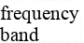 | 900/1800MhZ
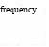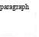 | Beidou | 1561.098MHz
 | GPS | 1575.42MHz
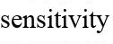 | Acquisition | -148dBm(cold)/-163dBm(hot)
 | Tracking (tracking) | -165dBM
 | power consumption | Acq:37mW,Tracking:27mW
 | support | Obtain MAC address, save power
 | support | Optional, Bluetooth anti-lost feature
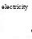 | Working Voltage | 3.5-4.2V DC
 | voltage fluctuation | 3.3-4.5V DC
 | operating current | Sleep 0.3mA (maintain clock)  Standby 3.3mA (3-minute heartbeat), positioning 60mA (LTE+GPS)
 | Built-in battery | 1500mAh high-voltage high-capacity polymer lithium battery
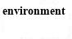 | Operating Temperature | -20℃~+70℃
 | Ultimate operating temperature | -30℃~+75℃
 | Storage temperature | -40℃~+85℃
 | relative humidity | 5%~95%
 | Gsensor | built-in
 | GPS | Support global GPS and Beidou
 | LED indicator light | GPS (blue), GSM (green), Power (red)
 | SIM interface | Nano, push-push side insertion, compatible with 2*2 eSIM
 | USB | Option 1: Type-C, charging + downloading, testing, activating battery  Option 2: Magnetic attraction function, utilizing the 10-pin connector of the motherboard
 | Simulated voice | Built-in single microphone (interrupt detection + recording), with options for surface mount or wire bond depending on appearance
 | horn | 8Ω, 1.2W or 4Ω, 2.4W
 | watchdog | Support, chip comes with it
 | antenna | GPS: FPC or LDS (with spring clips on the mainboard)  LTE: FPC or LDS (mainboard with spring clip) WIFI: the mainboard comes with a ceramic patch antenna
 | Smart wake-up/sleep | Support, timing or Gsensor
 | positioning | Support, scheduled positioning, intelligent positioning, and super power-saving positioning
 | WIFI positioning | support
 | Bluetooth anti-lost | support
 | Anti-theft recording | support
 | FOTA | support

