2G+4G charging type GPS tracker for vehicles
Product User Manual

Product model: (W07A/B/C/D)
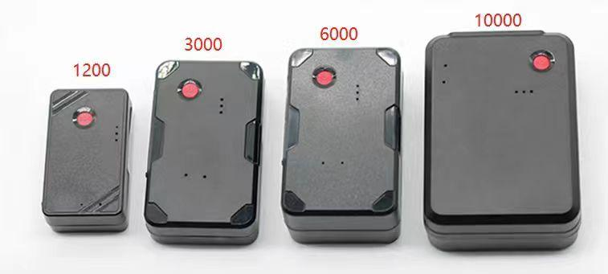

Legal Notice:
First of all, we would like to thank you for using this product. If you have agreed to the following terms, you will receive the support and services we provide. If you have any questions about this, please feel free to contact us. If you cannot accept the following terms, please stop using this manual.
The ownership of this manual belongs to the distributor. Any rights not expressly granted in this manual are reserved. Without the prior written permission of the distributor, no unit or individual may copy, transmit, distribute, use, or disclose the information about the products in this manual, as well as any images, tables, data, and other information contained in this manual.
Reading this document without the prior written consent of the distributor does not grant the reader any rights to use any marks appearing in this document, whether impliedly, estoppel, or otherwise.
The storage and use of this product should be conducted in accordance with the product manual, relevant contracts, or applicable laws and regulations.
The dealer reserves the right to modify and improve the products described in this manual without prior notice, and also reserves the right to revise or withdraw this manual at any time. If there are any unclear texts in this user manual, please promptly consult with the agent or seller.
Special statement: This product is only for anti-theft use in terminal vehicles and is strictly prohibited for illegal purposes
For the purpose of use, otherwise, all legal responsibilities arising therefrom shall be borne by the user.

catalogue
1. Product Features 3
II. Product Installation Instructions 4
III. Product Parameters 4
IV. Basic product functions 6
V. Analysis and Troubleshooting of Common Issues 6
VI. Precautions 7
VII. After-sales Service 8

1. Product Features
- 4G built-in antenna supports all networks, with a highly integrated design
- Wire-free, with built-in strong magnet
- Real-time location tracking, track playback
- GPRS/SMS (SMS query notification) remote monitoring
- 4 types of batteries with different capacities (1200mAh/3000mAh/6000mAh/10000mAh)
- Overspeed alarm, fence alarm
- Intelligent power saving, static dormancy, and online with vibration
- Multiple working modes can be switched
- GPS+BD+LBS+WiFi quadruple positioning

II. Product Installation Instructions
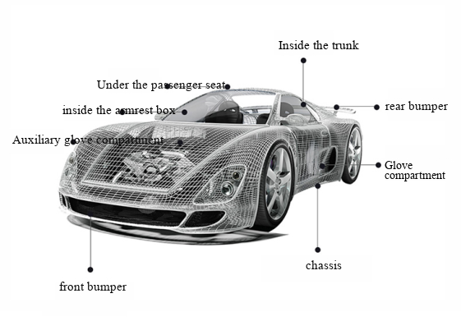

III. Product Parameters
Specification content | Specifications
Size (bare machine) | Type A: 57*33*19mm (length * width * thickness)  Type B: 75*45*21mm (length * width * thickness)  Type C: 75*45*31mm (length * width * thickness)  Type D: 85*61*31mm (length * width * thickness)
weight | Type A: 40.2g (excluding magnet)  Type B: 95.1g (including magnet)  Type C: 146g (including magnet)  Type D: 216.5g (including magnet)
Built-in battery | 1200/3000/6000/10000mAh（3.7V）
charging voltage | DC 5V/600mA（type-c）
Operating Temperature | -20°C to+60°C
Storage temperature | -20°C to+70°C
sensor | Precision vibration sensor
frequency band | LTE-FDD:B1/B2/B3/B4/B5/B7/B8/B28/B66  GSM/GPRS/EDGE 850/900/1800/1900MHZ
Communication module brand/chip model | SIMcom A7070SA
root mean square error | S degree
Dynamic output range | -15~-108dbm
reception sensitivity | -107dbm
Maximum frequency error | ±0.1ppm
sensitivity | Cold start: -147 dbm  Hot start: -155 dbm  Reacquisition: -158 dbm  Tracking: -160 dbm
positioning accuracy | ＜5m
First positioning time | Cold start: average 32 seconds
LTE 4G antenna | built-in
GPS antenna | built-in
LED indicator light | Power supply, indicating status
transmission protocol | TCP
Power detection | The indicator light is on when powered on
data reporting | Update GPS data in real-time and support customer customization
electronic fence | TBD
Driving behavior detection | If the vehicle's driving speed exceeds the set speed, upload an overspeed alarm
GPS data | Real-time location update
Vibration alarm | Reporting vehicle vibration in a secured state

IV. Basic functions of the product
content |  | function | Instructions
positioning function | Regular tracking |  | Return positioning information such as longitude and latitude at set intervals.
positioning function | Overspeed alarm |  | When driving over the speed limit, the GPS tracker will send an alert to your phone
positioning function | electronic fence |  | If the vehicle travels beyond the designated area, an alarm message will be sent to the platform
positioning function | historical trajectory |  | It can replay the driving trajectory for 365 days, including the speed, direction, and dwell time at that time
positioning function | Fleet management |  | One mobile phone can manage multiple devices, or one device can be managed by multiple mobile phones

V. Analysis and troubleshooting of common problems
The product displays a steady yellow and blue light, which indicates normal online positioning. If the lights start flashing, please follow the steps below to analyze and troubleshoot the issue.
Fault phenomenon | Fault Analysis | treatment method
Blue light flashing slowly | Check whether the terminal is being used in an area with poor GPS signal, such as near tall buildings or in underground parking lots | Drive the vehicle to a location with good signal and use the terminal
Blue light flashing slowly | Determine whether the vehicle's front windshield has a metal heat-resistant film that may affect signal reception | If there is a tint film, swap the device to another vehicle to test if the blue light stays lit. If the test is successful on another vehicle without a tint film, it indicates that the issue is caused by the tint film on the original vehicle
Blue light flashing slowly | Determine whether there is a jammer or signal blocker on the vehicle or in the surrounding area | If there is a jammer or interference source, remove it and try reinstalling
Blue light flashing | chip failure | return to factory for repair
Yellow light flashing quickly | Check if the SIM card is properly installed | Check if the SIM card is properly installed
Yellow light flashing quickly | Check whether there is dirt or poor contact on the metal surface of the SIM card | Wipe the metal chip surface with a clean cloth or repeatedly insert and remove the card several times
Yellow light flashing slowly | Determine whether the vehicle is located in a place without mobile network coverage, such as an underground parking lot | Please drive the vehicle to a place with good network signal and try reinstalling
Yellow light flashing slowly | Check whether the server backend is functioning properly | Inquire whether the backend management platform server is functioning normally
Yellow light flashing slowly | Determine whether the SIM card status is normal | Check whether the card status is normal through the SIM card inquiry platform
Yellow light flashing slowly | Determine whether there is a jammer or signal blocker on the vehicle or in the surrounding area | If there is a jammer or interference source, remove it and try again

VI. Precautions
- Please take care to prevent water damage to electronic products.
- Please insert the SIM card before installation and ensure that no password is set on the SIM card, otherwise the device will not work properly.
- The USB port on the terminal device is exclusively for factory testing and is not a charging port for the device. Please refrain from using it for charging or any other purposes.
- The installation location must be above an area that is not obstructed by substances that absorb electromagnetic waves (such as metal or explosion-proof heat-insulating film).
- Do not expose the device to liquids or operate it with wet hands.
- Do not throw the device into fire
- The device may not function when the temperature is below -20℃ or above +60℃.
- When the vehicle is located in an underground parking lot, tunnel, or garage, it will affect the positioning signal. There may be blind spots in the communication network signal, causing the device to be unable to monitor. When the vehicle exits these areas, the device will automatically resume normal operation.
- In case of any abnormalities, please do not attempt to repair it yourself. The manufacturer will not be held responsible for any damages caused by connecting non-original accessories or disconnecting the connections between various components.
- This product is a safety driving assistance product, and any losses caused by malfunctions or loss of information are not related to our company.
- This product has passed the international CE certification, but due to the complex electromagnetic environment inside vehicles, there is a possibility that this product may cause electromagnetic interference with the electrical equipment inside certain vehicle models.
- Please refrain from installing or operating this product while the vehicle is in motion.
- Please do not connect the uninterruptible power supply without authorization, as it may cause malfunctions in your car or product. For installation matters, please be sure to consult a professional.
- Please avoid subjecting this product to strong impacts or vibrations, as this may damage the product, resulting in malfunction or inoperability.
- The normal operating temperature range for this product is from -20 degrees Celsius to 65 degrees Celsius. Operating outside this temperature range may result in product malfunction, fire, or explosion.

VII. After-sales Service
1. This product is eligible for a three-month replacement guarantee and one-year warranty service from the date of shipment. During the warranty period, if the equipment is damaged due to non-human factors or product quality issues, please contact the dealer for timely resolution.
2. Damages caused by customers' unauthorized disassembly or force majeure events (such as floods, vehicle accidents) will not be repaired.
3. After the warranty period expires, for any product damage or malfunction caused by use, a fee for the cost of repair materials will be charged.
4. Provide customers with free consultation and technical services related to product purchase, usage, and APP installation.

